Prometic Report List

**Chris Johnson July 2016**

**Version 0.12**

|  |  |  |
| --- | --- | --- |
| Version number | Description | Date of version |
| 0.1 | First draft | 10th March 2016 |
| 0.2 | Moved Currency rates to System Reports  Added Actual Budgets GL Group Maps  Added General Ledger Journal Entries  Updated Lot Traceability to include batch numbers | 18th March 2016 |
| 0.3 | Added reports   * Closing Interco Balances * Open Purchase Zero Value * Missing RI2 GL Groups | 8th April 2016 |
| 0.4 | Added reports   * Open Requisition Report * Gen Ledger Control Panel | 13th April 2016 |
| 0.5 | Added report   * GL Center Summary | 14th April 2016 |
| 0.6 | Added report   * GL Cash Position | 15th April 2016 |
| 0.7 | Added report   * Supplier Changes   Update table formats on front page | 19th April 2016 |
| 0.7.1 | Amended report   * Requisition Users – added co. name, product class, currency & amended colours | 20th April 2016 |
| 0.8 | Added report   * GL Resin Rev vs Cos * Closing Interco Balances3 * GL Interco Balances * Job Lot Stock * Purchase Order History * Purchases by Supplier   Amended Report   * Open Requisition Report – amended format * General Ledger Journal Entries | 1st June 2016 |
| 0.8.1 | Amended Report   * Inventory Inspection Times – changed to allow filtering by months | 2nd June 2016 |
| 0.8.2 | Report signed off   * Inventory in Inspection | 6th June 2016 |
| 0.8.3 | Report signed off   * Open Purchase Order Stock | 6th June 2016 |
| 0.9 | Added report   * GL Codes * GL Balances and Mvmts * GL Balances and Mvmts BG * Trial Balance | 13th July 2016 |
| 0.10 | Added Reports   * Labour Logged Per Week * Lot Traceability with Labour | 20th July 2016 |
| 0.11 | Added reports   * Lot Traceability * Stock Levels with Labour * Reports System Refresh * Review of Reports   Removed Reports   * Job Lot Stock * Lot Traceability with Labour | 2nd September 2016 |
| 0.12 | Added Reports   * WarehouseStockSearch * SalesOrderStats * GL Balances and Mvmts BV * Inventory Inspection Times Supplier Lots | 1st November 2016 |

**Distribution List**

|  |  |  |  |
| --- | --- | --- | --- |
| Name | Position | Date sent | Version |
| Sophie Talon-Bergeron | Finance Manager | * 10th March 2016 | 0.1 |
| * 13th April 2016 | 0.4 |
| * 1st June 2016 | 0.8 |
| * 13th July 2016 | 0.9 |
| Bianca Vasquez | Financial Analyst | * 10th March 2016 | 0.1 |
| * 13th April 2016 | 0.4 |
| * 1st June 2016 | 0.8 |
| * 13th July 2016 | 0.9 |
| Liz Collins | Financial Controller | * 10th March 2016 | 0.1 |
| * 13th April 2016 | 0.4 |
| * 1st June 2016 | 0.8 |
| Benjamin Hémond | Procurement Specialist | * 10th March 2016 | 0.1 |
| Hassan Mamdani | Research Scientist Computational Chemist | * 10th March 2016 | 0.1 |
| * 1st June 2016 | 0.8 |
| * 13th July 2016 | 0.9 |
| * 20th July 2016 | 0.10 |
| * 1st November 2016 | 0.12 |
| David Franklin | Head of Financial Planning and Analysis | * 10th March 2016 | 0.1 |
| * 1st June 2016 | 0.8 |
| * 20th July 2016 | 0.10 |
| Jacqueline Richard | Head of Financial Reporting | * 10th March 2016 | 0.1 |
| * 1st June 2016 | 0.8 |
| * 13th July 2016 | 0.9 |
| Bruce Pritchard | COO | * 10th March 2016 | 0.1 |
| Greg Weaver | CFO | * 10th March 2016 | 0.1 |
| * 1st November 2016 | 0.12 |

**Introduction**

This is a brief list of all reports that are currently available as held within the Syspro ERP system with a brief description of

* What the report does
* What the parameters of the report relate to
* What the report looks like

Any reports that are held in the development folder are awaiting sign off from the business before being released.

Any reports that have been written limiting them to a single company are scheduled to be removed as soon as replacements have been signed off and therefore have not been included in this document.

**Report Stats**

Version 0.1

* 27 Live Reports
* 26 Reports in development (awaiting testing)

Version 0.12

* 30 Live Reports
* 27 Reports in development (awaiting testing)

**Biggest Requestors**

Version 0.1 (All reports and requests)

* Bianca Vasquez – 11
* Liz Collins – 8

Version 0.12 (live reports only)

* Finance Liz Collins 6
* Finance Bianca Vasquez 5
* Finance David Franklin 4
* Manufacturing Matt Fantham 3
* QC Andrew Hafford 2
* Manufacturing Ross Moore 2
* Sales Shrinal Inamdar 2
* Finance Kirsty Wells 1
* Finance Becky Glover 1
* QC Tracy Moore 1

Contents

Folder – System Reports 5

Batch Profitability 5

Currency Rates 6

Job Lot Breakdown 7

Folder – System Accounts Payable 8

AP Aged Analysis Alt 8

AP Unpaid Assets 9

Payment Run 10

Folder – System Assets 11

Fixed Asset List Live 11

Folder – System General Ledger 12

Closing Interco Balances 12

Gen Ledger Control Panel 13

GL Resin Rev Vs Cos 14

GRN Unpaid assets 15

Folder – System Inventory 16

Inventory Inspection Times 16

Inventory in Inspection 17

Lot Retesting 18

Stock Levels 19

Stock Levels with Labour 20

Folder – Lot Traceability 21

Lot Traceability 21

WarehouseStockSearch 22

Folder – System Management Accounts 23

Folder – System Purchase Orders 24

Purchase Order Changes 24

Open Purchase Orders 25

Open Purchase Orders Stock 26

Open Purchase Zero Order 27

Open Requisition Report 28

Requisition users 29

Folder – System Sales Orders 30

Sales Orders Status 30

Sales by Job 31

Sales Order KPI 32

Sales Order Stats 33

Folder – System WIP 34

Job Lot Output 34

Labour Logged Per Week 35

Folder – Development 36

Actuals Budgets GL Group Maps 36

Actuals Budgets Report Index Maps 37

Actuals Budgets Balance Sheet 38

Closing Interco Balances 3 39

General Ledger Journal Entries 40

GL Balances and Mvmts 41

GL Balances and Mvmts BG 42

GL Balances and Mvmts BV 43

GL Cash Position 44

GL Center Summary 45

GL Codes 46

Gl Interco PL Accounts 47

Inventory Inspection Times Supplier Lots 48

Labour Ledger Comparison 49

Missing RI2 GLGroups 50

Payment Run 51

Pick List 52

Pick List Job Breakdown 53

Pick List Reserved Lots 54

Pick List Work Centre 55

Purchase Order Details 56

Purchase Order E Signature 57

Purchase Receipts History 58

Purchases by Supplier 59

Report System Refresh 60

Review of Reports 61

Trial Balance 62

Unpaid Assets Accounts Payable 63

# Folder – System Reports

## Batch Profitability

|  |  |
| --- | --- |
| Description | Provide detail of jobs that have been actioned within a timeframe for a company, including labour cost, material cost and the amount sold |
| Requested by | David Franklin |
| Delivered Date | Oct 2015 |
| Used by | PBL |

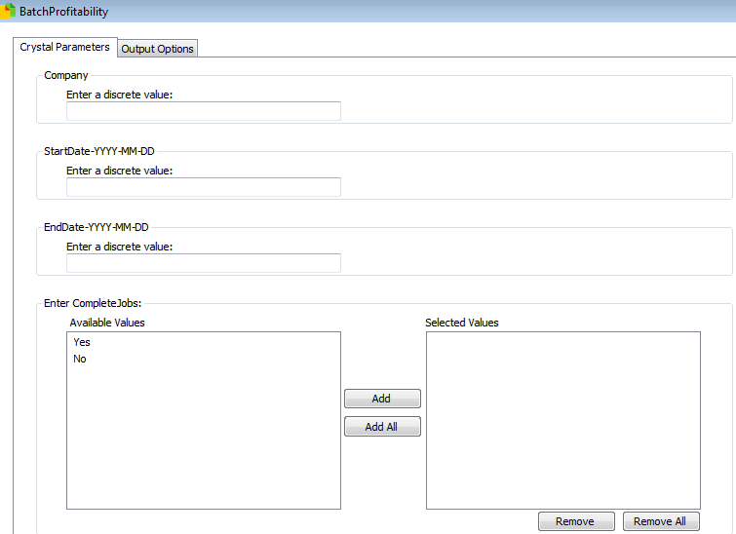Parameters

These are filters picked before running the report

* Company
  + The Syspro company ID to run against (PBL = 10)
* Start Date-YYYY-MM-DD
  + Beginning of the period to select jobs that started
* End Date-YYYY-MM-DD
  + End of the period to select jobs that started
* Complete Jobs
  + Yes – for only complete jobs
  + No – for only incomplete jobs

Final Report

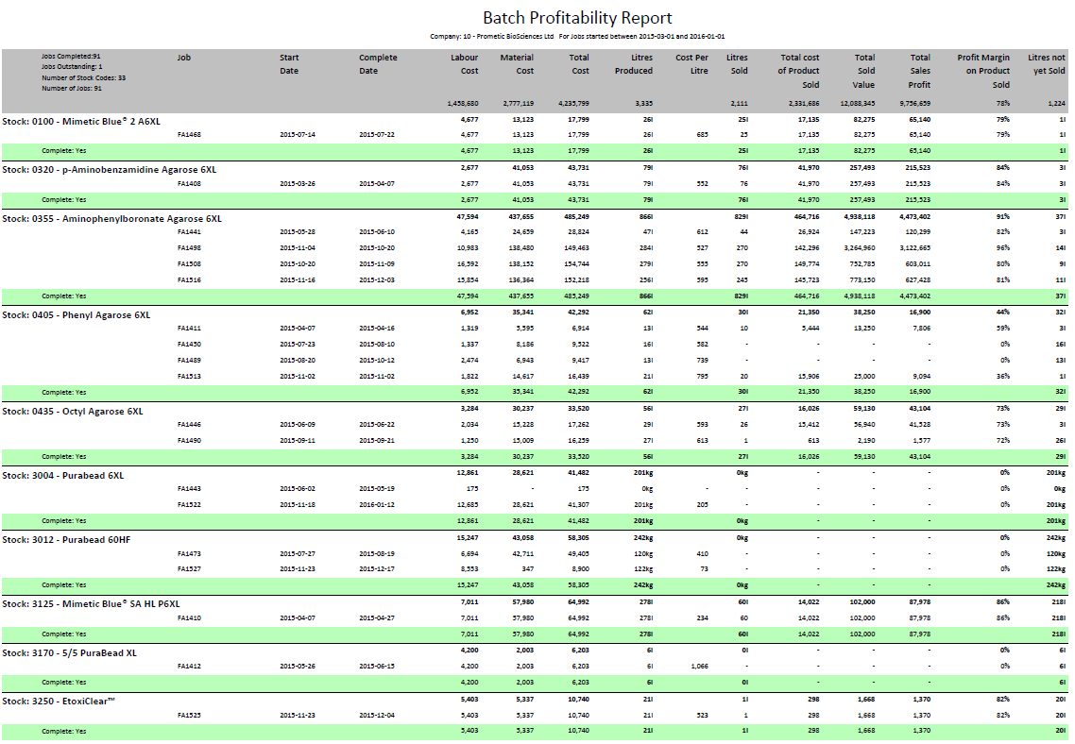

## Currency Rates

|  |  |
| --- | --- |
| Description | Details of historic currency rates |
| Requested by | Chris Johnson |
| Delivered Date | March 2016 |
| Used by | N/A |

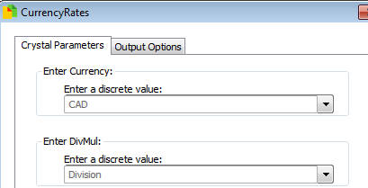Parameters

These are filters picked before running the report

* Currency
  + Choose currency to review
* DivMul
  + Division – show currency rates as a rate to divide figures by
  + Multiply – show currency rates as a rate to divide figures by

Final Report

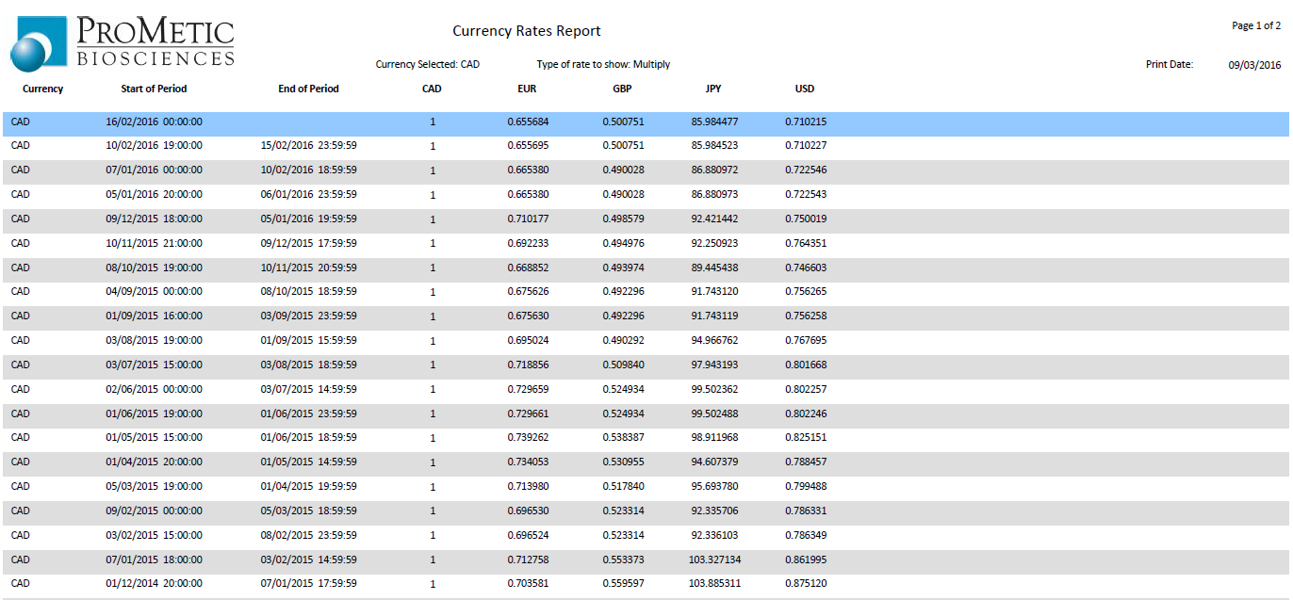

## Job Lot Breakdown

|  |  |
| --- | --- |
| Description | Syspro details of a job, showing labour, stock consumed, stock created and sales made |
| Requested by | David Franklin |
| Delivered Date | Nov 2015 |
| Used by | PBL |

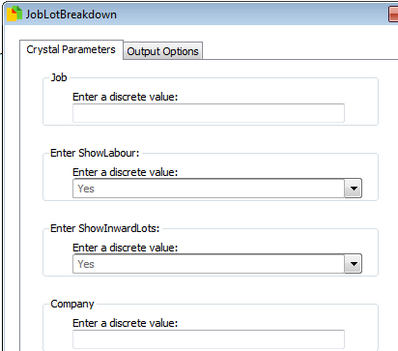Parameters

These are filters picked before running the report

* Company
  + The Syspro company ID to run against (PBL = 10)
* Job
  + The batch number to check
* Show Labour
  + Choose whether to show labour input into job
* Show Inward Lots
  + Choose whether to show Lots input into job

Final Report

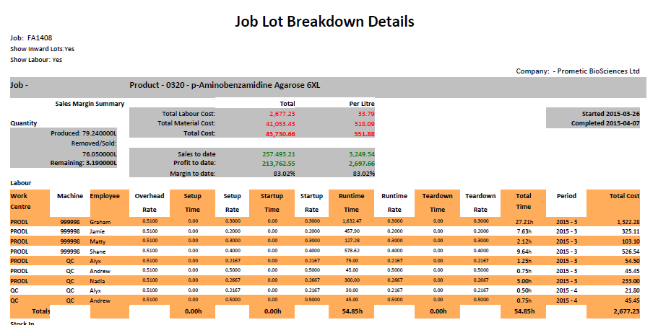

# Folder – System Accounts Payable

## AP Aged Analysis Alt

|  |  |
| --- | --- |
| Description | Revision of Syspro report correcting total fields |
| Requested by | Liz Collins |
| Delivered Date | Oct 2015 |
| Used by | PBL Finance |

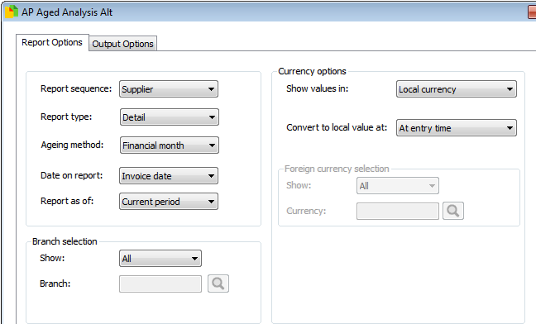Parameters

These are filters picked before running the report.

These parameters have been defined by Syspro.

Final Report

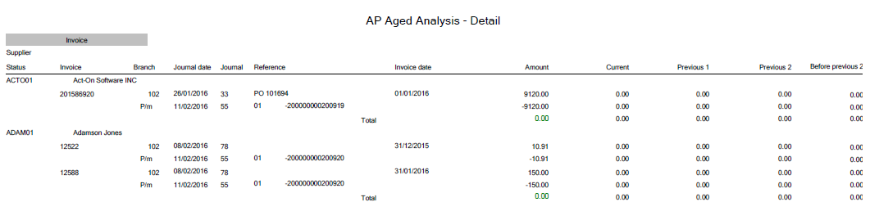

## AP Unpaid Assets

|  |  |
| --- | --- |
| Description | Accounts Payable – Unpaid Assets, created by Logi Solutions |
| Requested by | Bianca Vasquez |
| Delivered Date | - |
| Used by | PBI/PBL finance |

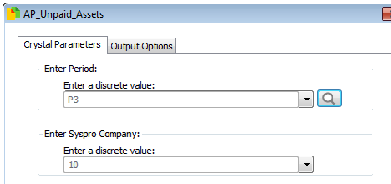Parameters

* Period
  + P1 = current period
  + P2 = previous period
  + P3 = previous period -1
* Syspro Company
  + The Syspro company ID to run against (PBL = 10)

Final Report

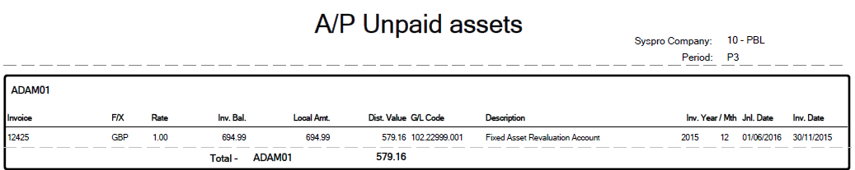

## Payment Run

|  |  |
| --- | --- |
| Description | Details of Payment Run with GRN matching for the creation of cheques |
| Requested by | Bianca Vasquez |
| Delivered Date | Dec 2015 |
| Used by | PBI Finance |

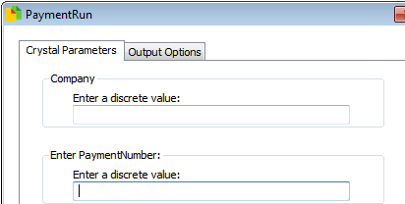Parameters

These are filters picked before running the report

* Company
  + The Syspro company ID to run against (PBL = 10)
* Payment Number
  + Syspro payment number to query

Final Report

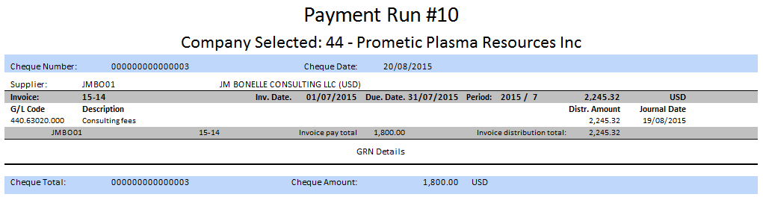

# Folder – System Assets

## Fixed Asset List Live

|  |  |
| --- | --- |
| Description | Details of fixed assets in Syspro |
| Requested by | Kirsty Wells |
| Delivered Date | Oct 2015 |
| Used by | PBL Finance |

Parameters

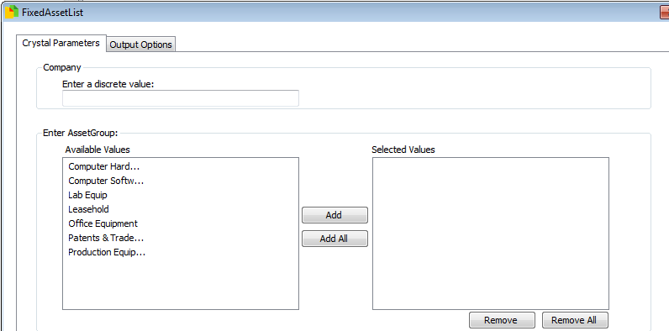These are filters picked before running the report

* Company
  + The Syspro company ID to run against (PBL = 10)
* Enter Asset Group
  + Pick which groups of assets that should be shown

Final Report

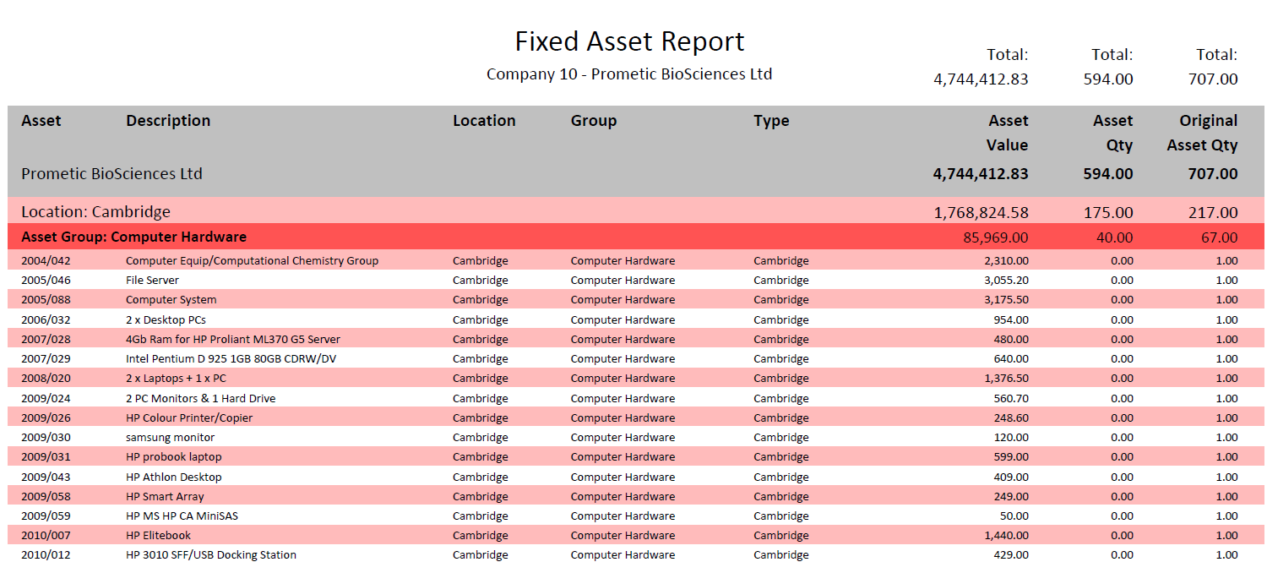

# Folder – System General Ledger

## Closing Interco Balances

|  |  |
| --- | --- |
| Description | Details of closing balances for intercompany payments |
| Requested by | Bianca Vasquez |
| Delivered Date | 7th April 2016 |
| Used by | PBI Finance |

Parameters

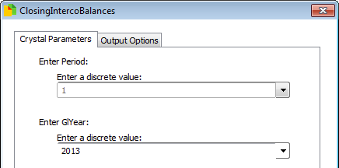These are filters picked before running the report

* Company
  + The Syspro company ID to run against (PBL = 10)
* Enter Period
  + Choose which GL period to review

Final Report

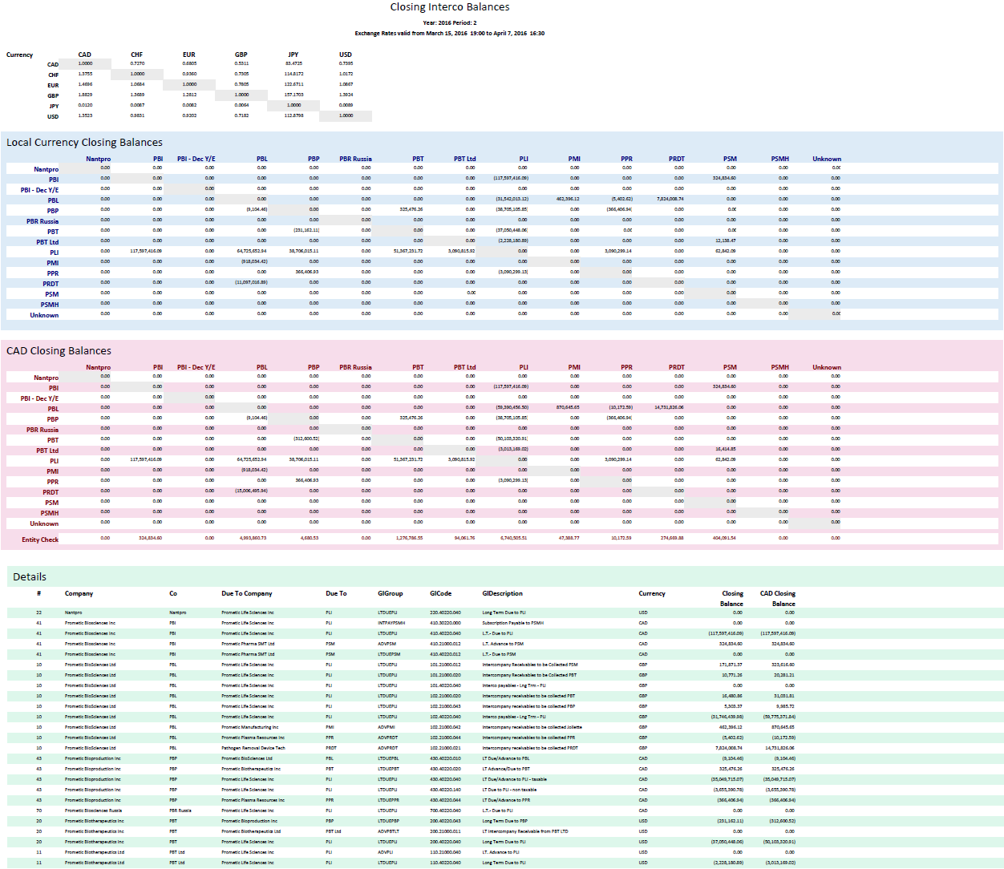

## Gen Ledger Control Panel

|  |  |
| --- | --- |
| Description | Details of current general ledger statistics |
| Requested by | Liz Collins |
| Delivered Date | 13th April 2016 |
| Used by | PBL Finance |

Parameters

No parameters required.

Final Report

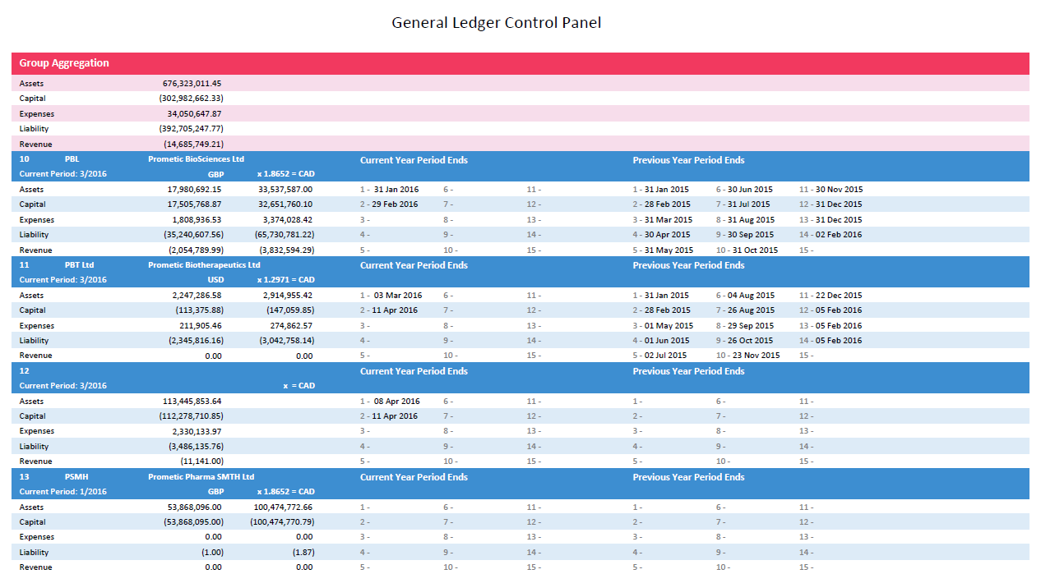

## GL Resin Rev Vs Cos

|  |  |
| --- | --- |
| Description | General Ledger Resin Revenues Vs Cost of Sales for PBL |
| Requested by | Becky Glover |
| Delivered Date | 18th April 2016 |
| Used by | PBL Finance |

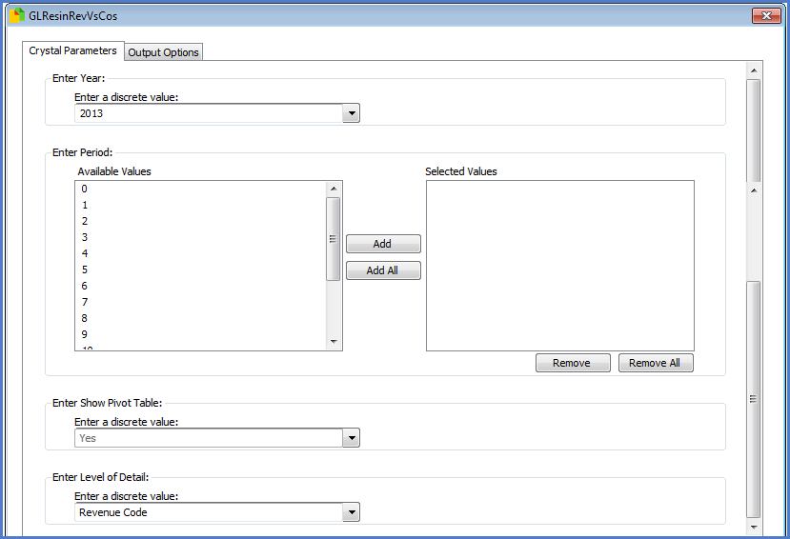Parameters

These are filters picked before running the report

* Year
  + The Syspro General ledger year to query
* Enter Period
  + Choose which GL period to review
* Show Pivot Table
  + If a pivot table is generated, the report does not export easily to excel
* Level of Detail
  + Define the level that data is grouped at in the report
  + Options: Revenue Code, Period, GL Code, Journal

Final Report

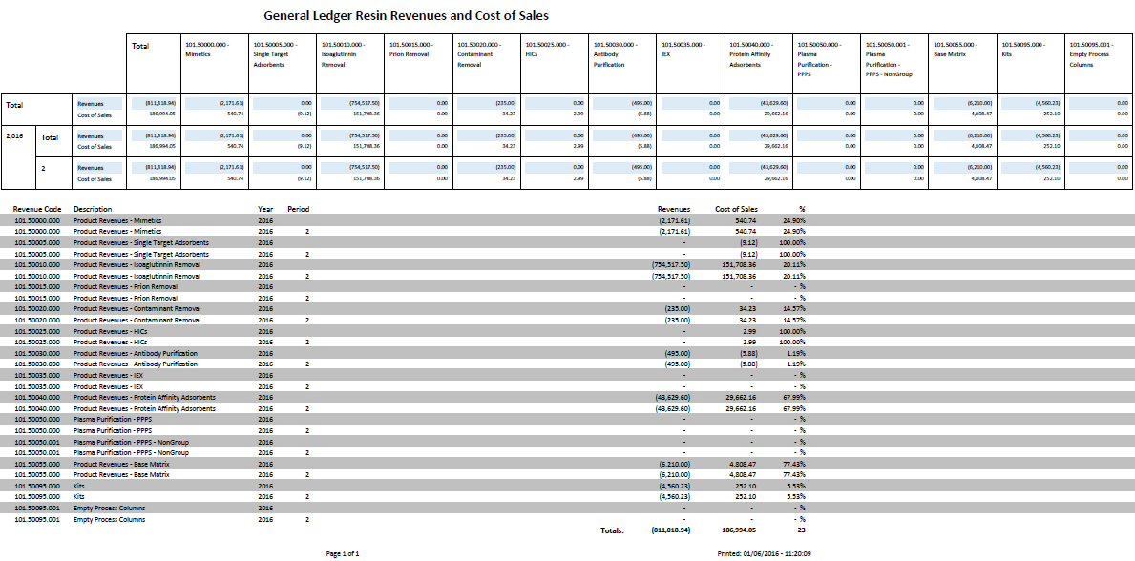

## GRN Unpaid assets

|  |  |
| --- | --- |
| Description | GRN Unpaid Assets – Logi solutions |
| Requested by | Bianca Vasquez |
| Delivered Date | - |
| Used by | PBI Finance |

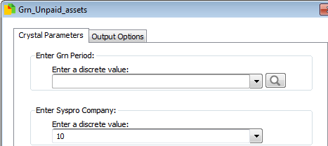Parameters

These are filters picked before running the report

* Company
  + The Syspro company ID to run against (PBL = 10)
* Enter Grn Period
  + Choose which GL period to review

Final Report

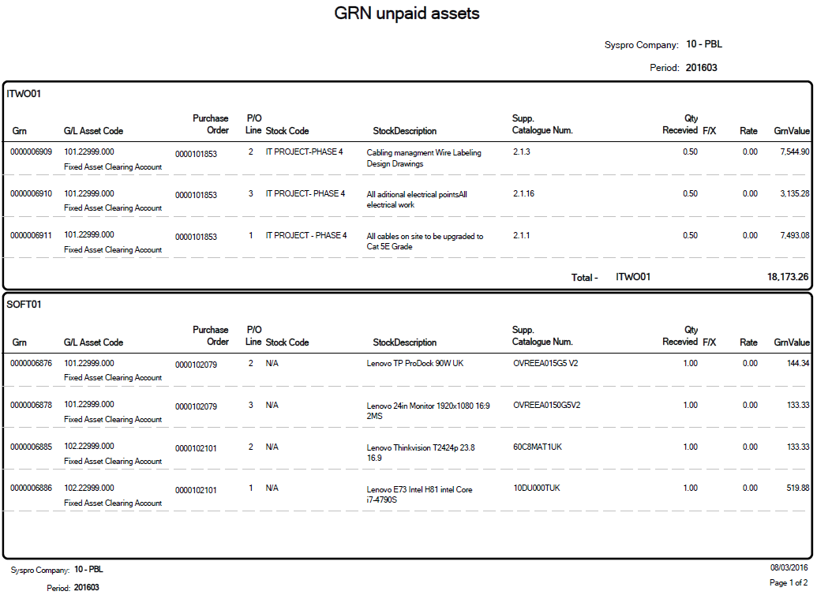

# Folder – System Inventory

## Inventory Inspection Times

|  |  |
| --- | --- |
| Description | Review of how long stock spends in inventory before being approved |
| Requested by | Andrew Hafford |
| Delivered Date | Feb 2016 |
| Used by | PBL QC & Finance |

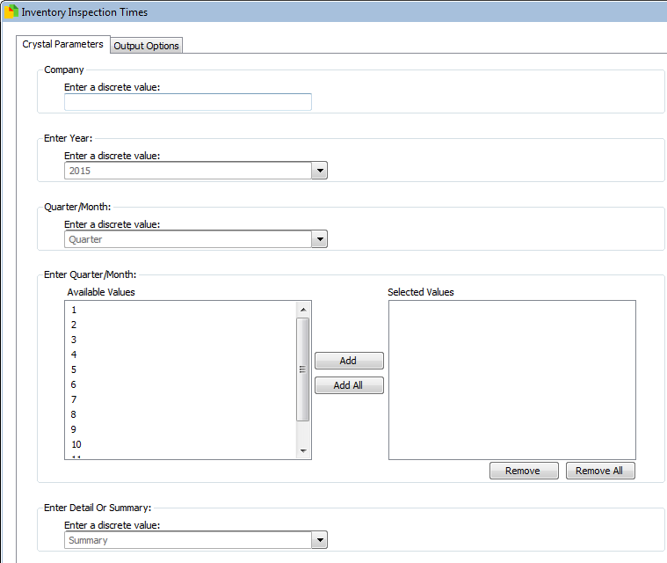Parameters

These are filters picked before running the report

* Company
  + The Syspro company ID to run against (PBL = 10)
* Year
  + Choose the year to review
* Quarter/Month
  + Choose whether to filter by quarter or month
* Enter Quarter/Month
  + Choose which quarters or months to filter by
* Detail or Summary
  + Detail – show each lot
  + Summary – show a summary line per stock code and delivery date

Final Report

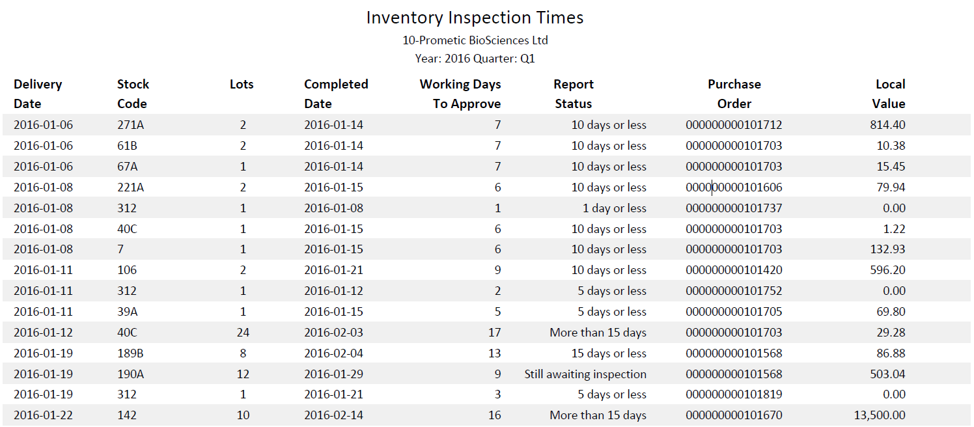

## Inventory in Inspection

|  |  |
| --- | --- |
| Description | Monitoring of items awaiting release from Inspection |
| Requested by | Matt Fantham |
| Delivered Date | 6th June 2016 |
| Used by | PBL Manufacturing, Finance & Purchasing |

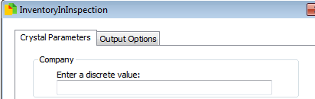Parameters

These are filters picked before running the report

* Company
  + The Syspro company ID to run against (PBL = 10)

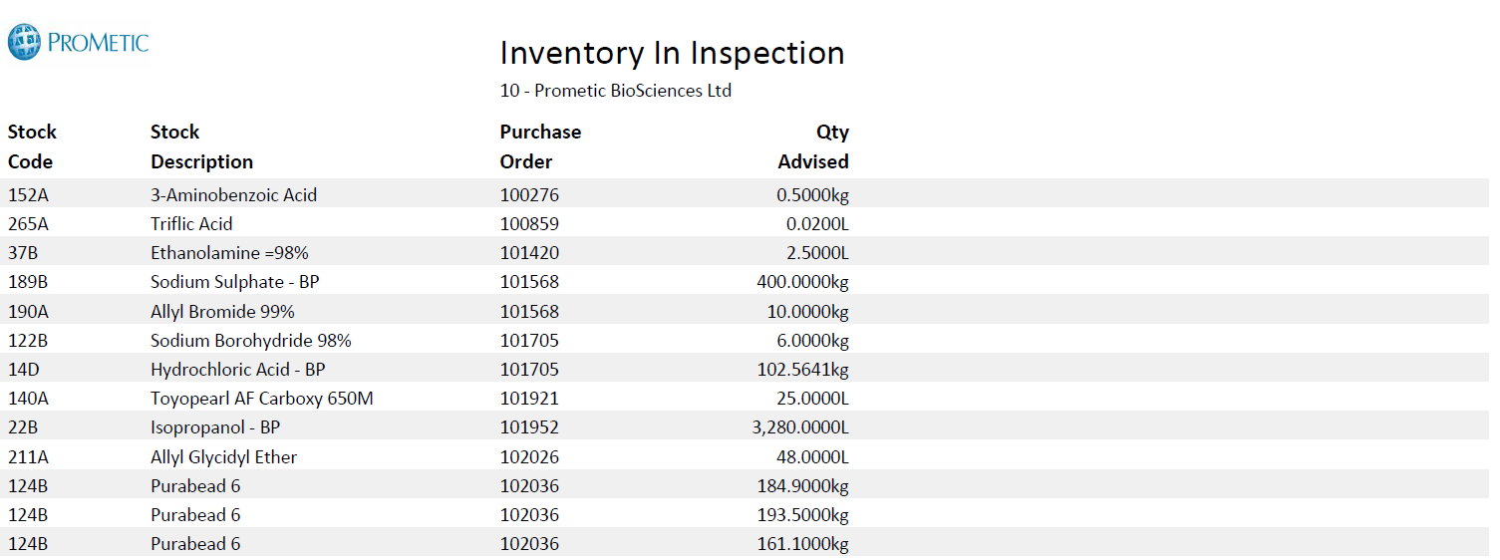

## Lot Retesting

|  |  |
| --- | --- |
| Description | Allows Quality Control to know which lots need retesting within a period |
| Requested by | QC |
| Delivered Date | Dec 2015 |
| Used by | PBL QC |

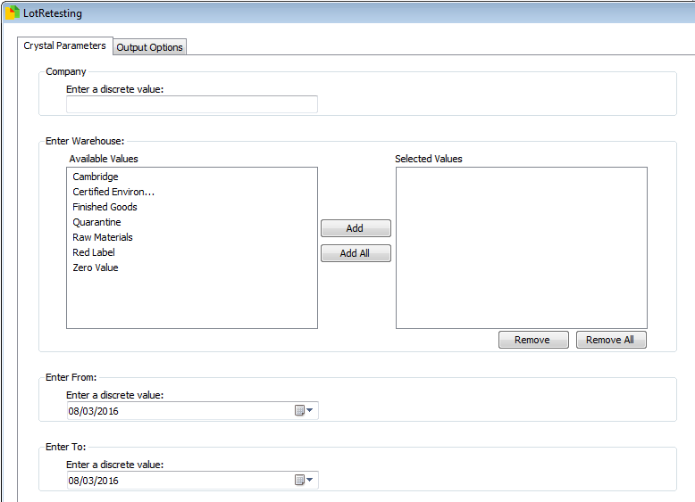Parameters

These are filters picked before running the report

* Company
  + The Syspro company ID to run against (PBL = 10)
* Warehouse
  + Which warehouse to review
* Enter From
  + Start of period for expiry dates
* Enter To
  + Start of period for expiry dates

Final Report

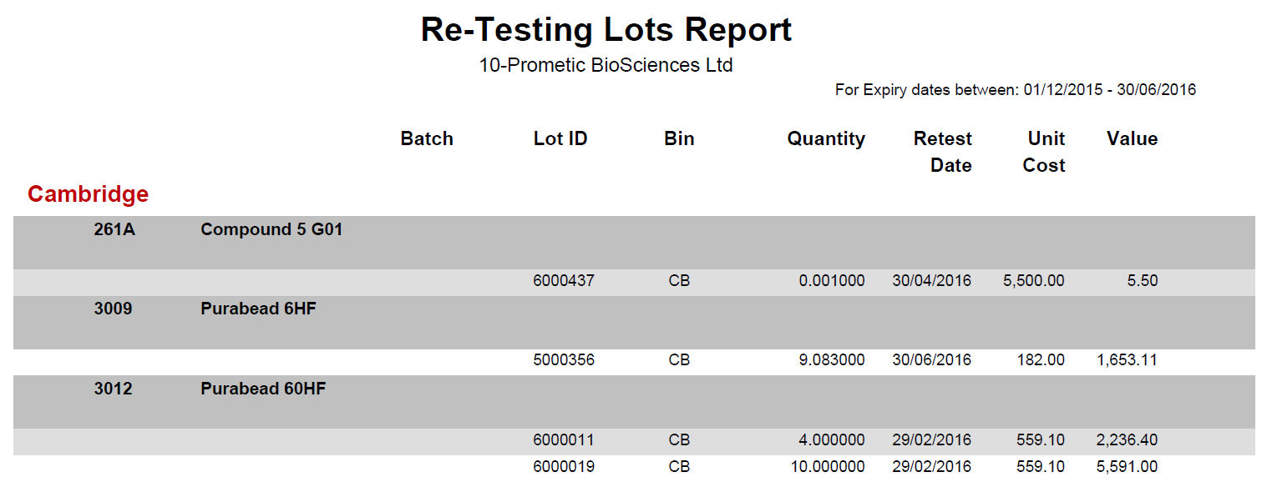

## Stock Levels

|  |  |
| --- | --- |
| Description | Details of all stock held in Syspro |
| Requested by | Liz Collins |
| Delivered Date | Nov 2015 |
| Used by | PBL Finance |

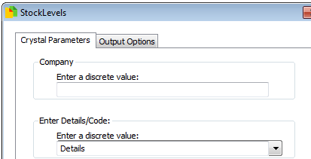Parameters

These are filters picked before running the report

* Company
  + The Syspro company ID to run against (PBL = 10)
* Details/Code
  + Details – show movements
  + Code – show overall level per stock code

Final Report

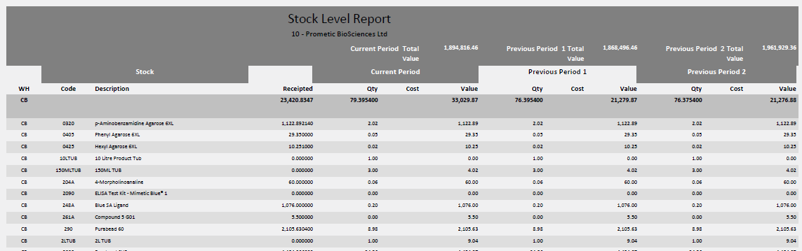

## Stock Levels with Labour

|  |  |
| --- | --- |
| Description | Shows a summary of inventory transactions |
| Requested by | David Franklin |
| Delivered Date | July 2016 |
| Used by | PBL Finance |

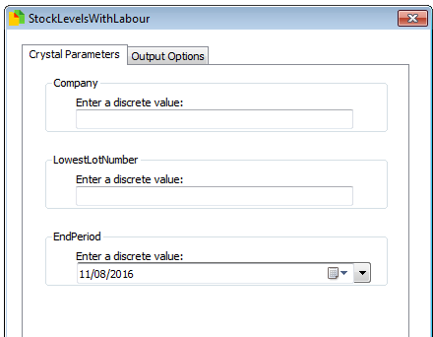Parameters

These are filters picked before running the report

* Company
  + The Syspro company ID to run against (PBL = 10)
* Lower Lot Amount
  + Choose which lots to return (PBL lots begin at 6000000)
* Period End
  + The end of the inventory transactions period to query

Final Report

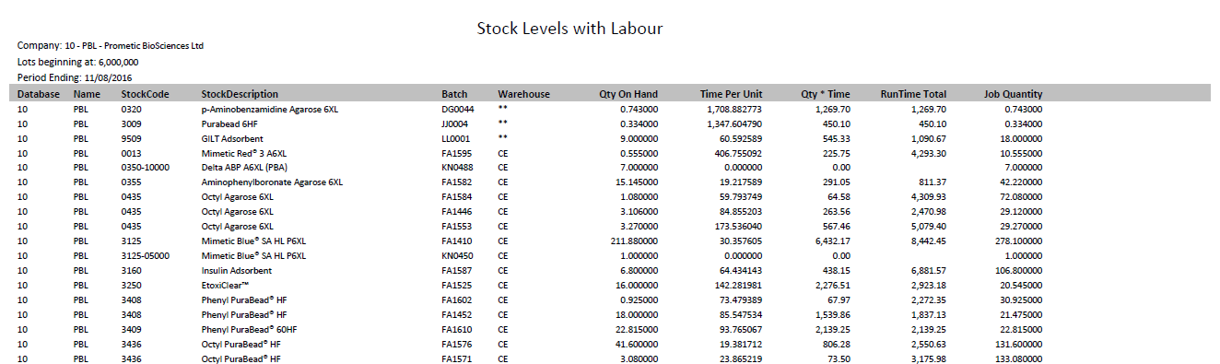

# Folder – Lot Traceability

## Lot Traceability

|  |  |
| --- | --- |
| Description | Allow query and tracing of Internal lots, batches or supplier lot number |
| Requested by | Tracy Moore |
| Delivered Date | 22nd August 2016 |
| Used by | PBL Quality Assurance |

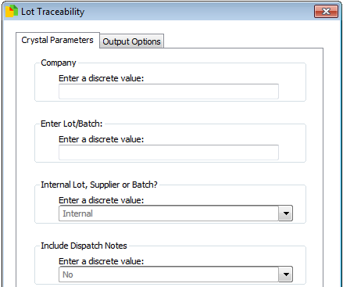Parameters

These are filters picked before running the report

* Company
  + The Syspro company ID to run against (PBL = 10)
* Lot/Batch
  + The lot or batch id that should be queried
* Internal Lot, Supplier or Batch
  + Internal – search internal lots
  + Supplier – search supplier lorsts
  + Batch – search Job/batch number
* Include Dispatch Notes
  + Whether to show when dispatch notes are generated

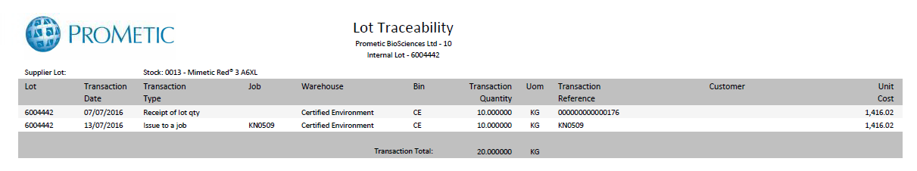

## WarehouseStockSearch

|  |  |
| --- | --- |
| Description | Allow query and tracing of Internal lots, batches or supplier lot number, grouped by warehouse |
| Requested by | Ross Moore |
| Delivered Date | October 2016 |
| Used by | Manufacturing |

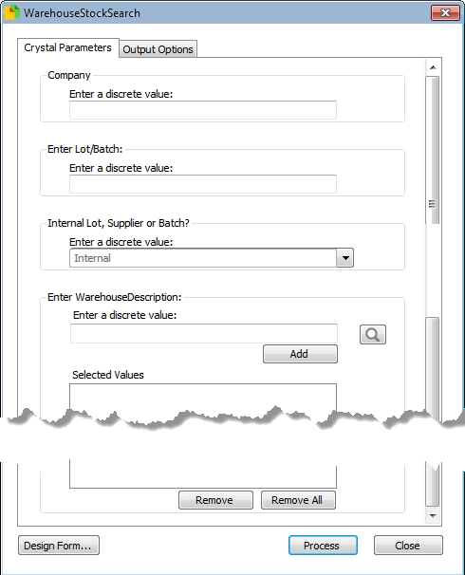Parameters

These are filters picked before running the report

* Company
  + The Syspro company ID to run against (PBL = 10)
* Lot/Batch
  + The lot or batch id that should be queried
* Internal Lot, Supplier or Batch
  + Internal – search internal lots
  + Supplier – search supplier lots
  + Batch – search Job/batch number
* Enter WarehouseDescription
  + Choose which warehouses to query

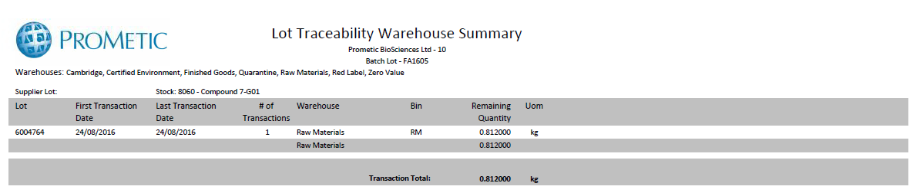

# Folder – System Management Accounts

This folder is a placeholder for the Actual & Budgets reports

# Folder – System Purchase Orders

## Purchase Order Changes

|  |  |
| --- | --- |
| Description | Monitoring of Purchase Orders to see changes in Price and Value |
| Requested by | Bianca Vasquez |
| Delivered Date | Dec 2015 |
| Used by | PBI Finance |

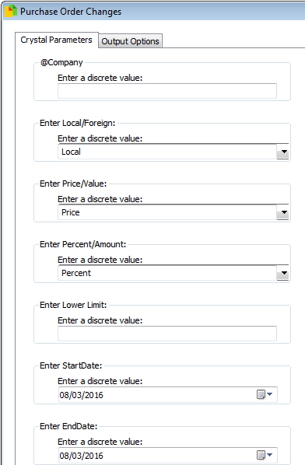Parameters

These are filters picked before running the report

* Company
  + The Syspro company ID to run against (PBL = 10)
* Local/Foreign
  + Whether to use the local or settlement currency figures for comparison
* Price/Value
  + Price – check differences in price
  + Value – check differences in value (price x quantity)
* Percent/Amount
  + Percent – check difference in percent
  + Amount – check difference in value
* Lower Limit
  + Only show changes about this amount
* Start Date
  + Start of period for changes
* End Date
  + End of period for changes

Final Report

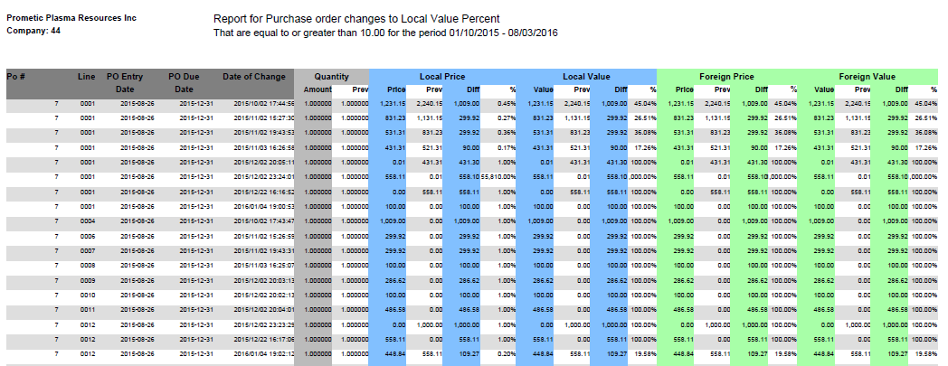

## Open Purchase Orders

|  |  |
| --- | --- |
| Description | Monitoring of Purchase Orders that are outstanding |
| Requested by | Liz Collins/Colin Martin |
| Delivered Date | Dec 2015 |
| Used by | PBL Finance & Purchasing |

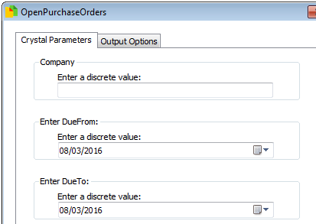Parameters

These are filters picked before running the report

* Company
  + The Syspro company ID to run against (PBL = 10)
* Due From
  + Start of due date period
* Due To
  + End of due date period

Final Report

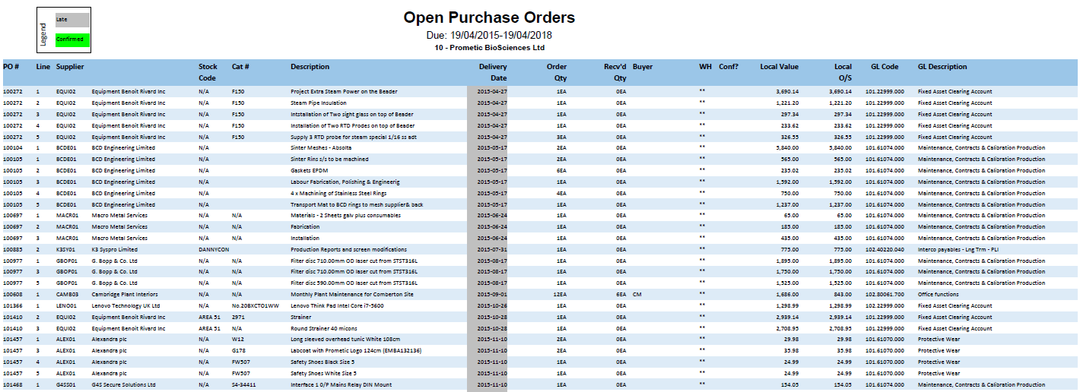

## Open Purchase Orders Stock

|  |  |
| --- | --- |
| Description | Monitor outstanding stock in purchase orders for manufacturing projects |
| Requested by | Matt Fantham |
| Delivered Date | 6th June 2016 |
| Used by | PBL Manufacturing |

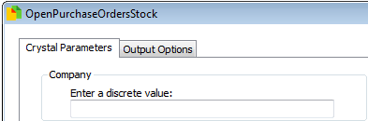Parameters

These are filters picked before running the report

* Company
  + The Syspro company ID to run against (PBL = 10)

Final Report

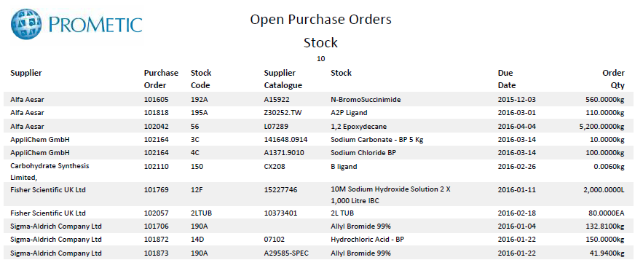

## Open Purchase Zero Order

|  |  |
| --- | --- |
| Description | Monitoring of Purchase Orders that are open and have a price of zero |
| Requested by | Matt Fantham |
| Delivered Date | 8th April 2016 |
| Used by | PBL Purchasing |

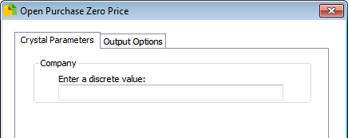Parameters

These are filters picked before running the report

* Company
  + The Syspro company ID to run against (PBL = 10)

Final Report

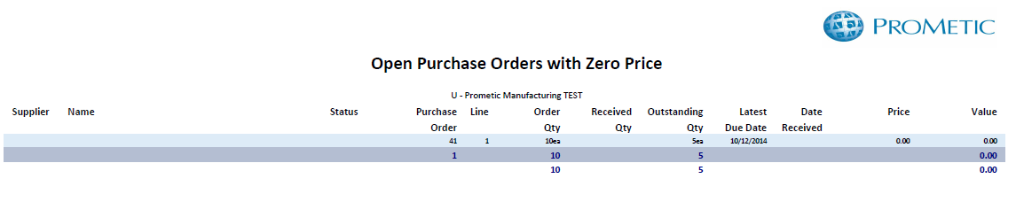

## Open Requisition Report

|  |  |
| --- | --- |
| Description | Monitoring of Requisitions that are outstanding |
| Requested by | Benjamin Hémond |
| Delivered Date | 13th April 2016 |
| Used by | PBI Purchasing |

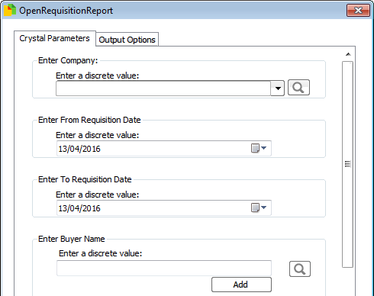Parameters

These are filters picked before running the report

* Company
  + The Syspro company ID to run against (PBL = 10)
* From Requisition Date
  + Beginning of period to query
* To Requisition Date
  + End of period to query
* Buyer Name
  + Buyer to query (if left blank then all buyers selected)

Final Report

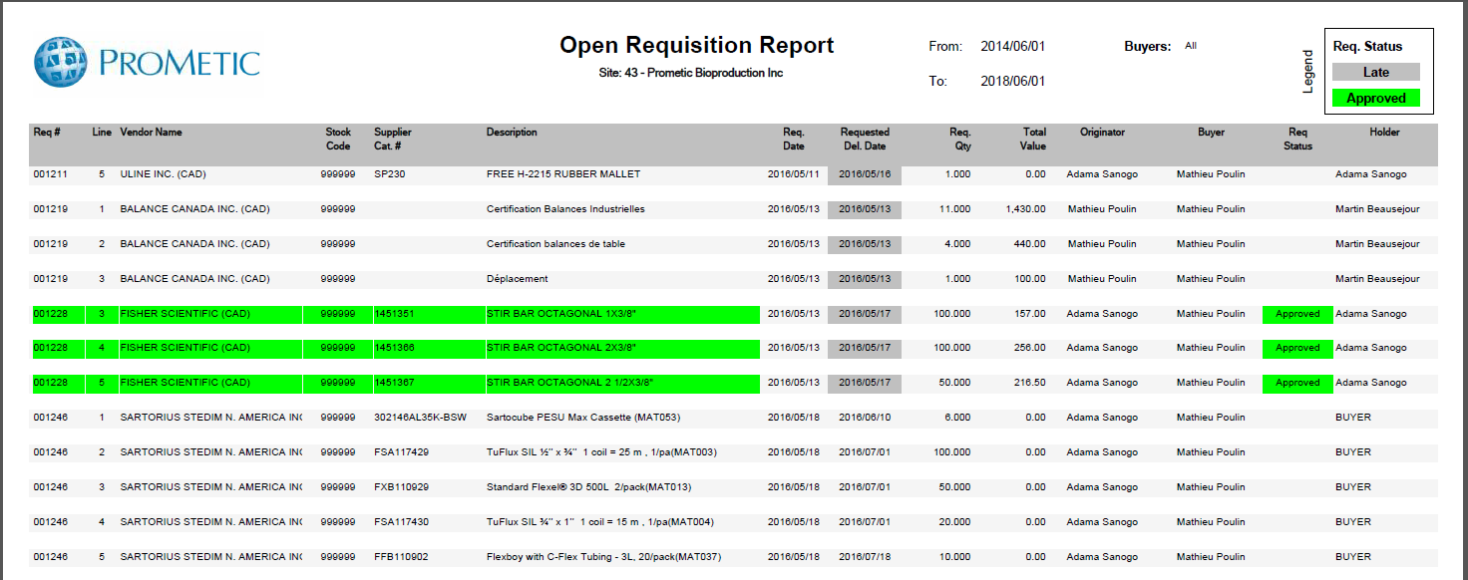

## Requisition users

|  |  |
| --- | --- |
| Description | Details of Syspro Users & their requisition approval limits |
| Requested by | Liz Collins |
| Delivered Date | Feb 2016 |
| Used by | PBL Finance |

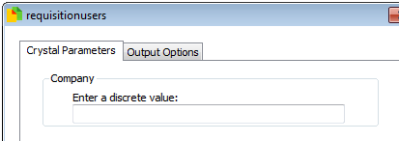Parameters

These are filters picked before running the report

* Company
  + The Syspro company ID to run against (PBL = 10)

Final Report

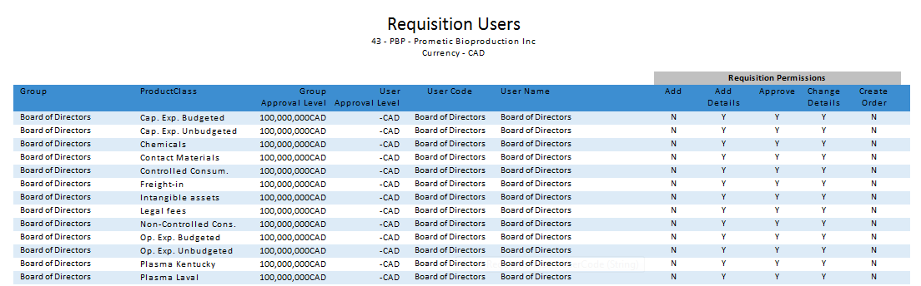

# Folder – System Sales Orders

## Sales Orders Status

|  |  |
| --- | --- |
| Description | Details of Sales Orders |
| Requested by | Liz Collins/Shrinal Inamdar |
| Delivered Date | Feb 2016 |
| Used by | PBL Sales/Finance |

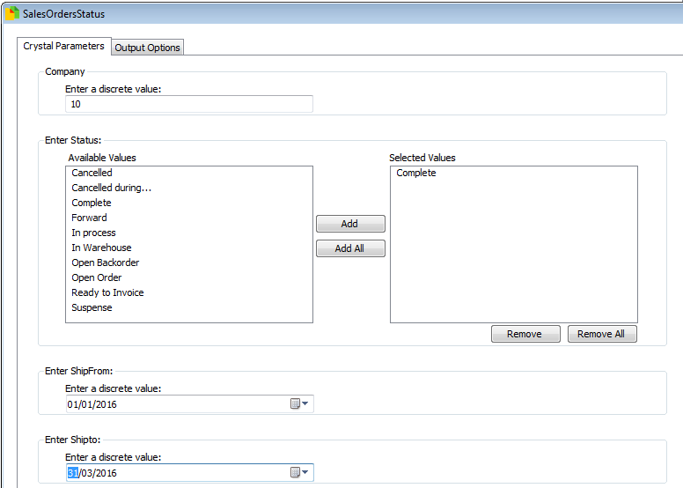Parameters

These are filters picked before running the report

* Company
  + The Syspro company ID to run against (PBL = 10)
* Status
  + Choose Sales Order Status
* Ship from
  + Start of ship date period
* Ship to
  + End of ship date period

Final Report

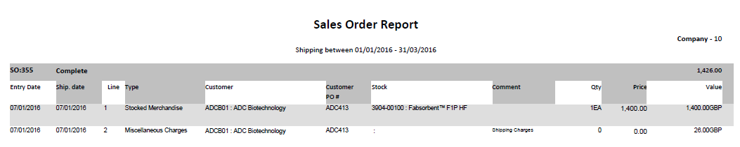

## Sales by Job

|  |  |
| --- | --- |
| Description | Details of Sales that are related to a manufacturing jobs |
| Requested by | Shrinal Inamdar |
| Delivered Date | Jan 2016 |
| Used by | PBL Sales |

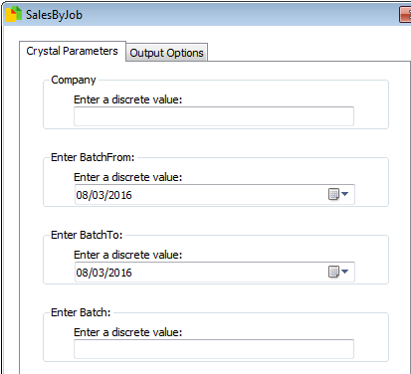Parameters

These are filters picked before running the report

* Company
  + The Syspro company ID to run against (PBL = 10)
* Batch from
  + Start of transaction date period
* Batch to
  + End of transaction date period
* Batch
  + Syspro Job to review

Final Report

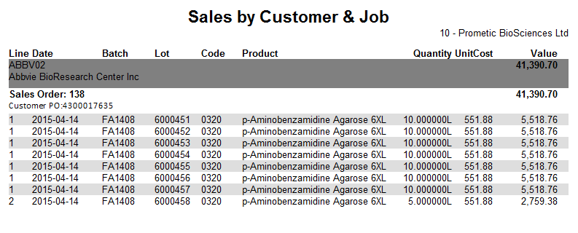

## Sales Order KPI

|  |  |
| --- | --- |
| Description | Monitoring of whether production have met the agreed date in Sales |
| Requested by | Ross Moore |
| Delivered Date | Feb 2016 |
| Used by | PBL Manufacturing |

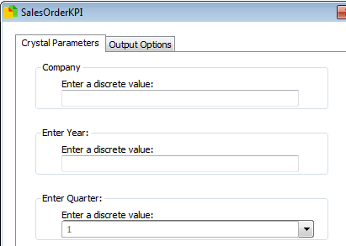Parameters

These are filters picked before running the report

* Company
  + The Syspro company ID to run against (PBL = 10)
* Year
  + Year to review
* Quarter
  + Quarter to review

Final Report

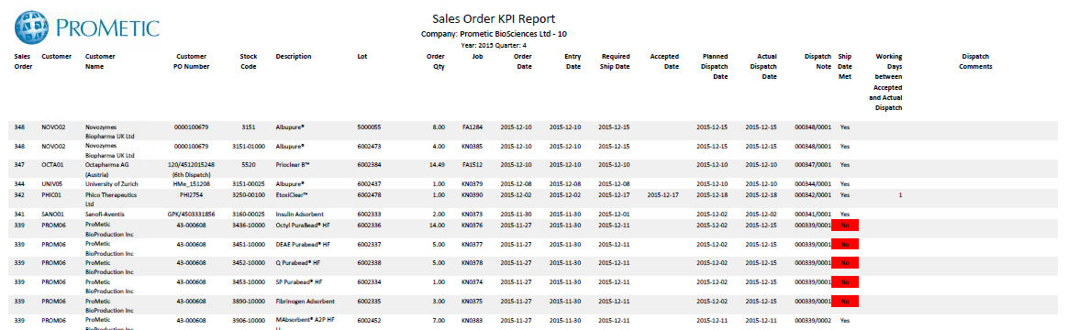

## Sales Order Stats

|  |  |
| --- | --- |
| Description | Automated Sales reporting for board |
| Requested by | Shrinal Inamdar |
| Delivered Date | September 2016 |
| Used by | PBL Sales |

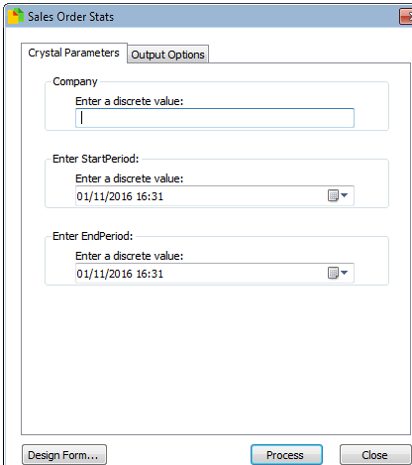Parameters

These are filters picked before running the report

* Company
  + The Syspro company ID to run against (PBL = 10)
* StartPeriod
  + Beginning of period to review
* EndPEriod
  + End of period to review

Final Report

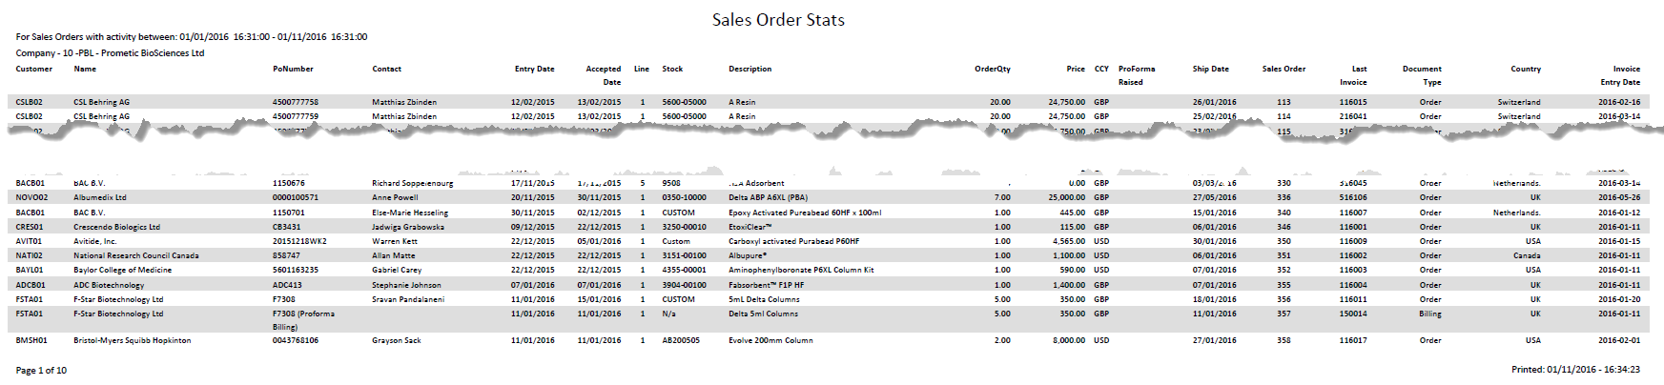

# Folder – System WIP

## Job Lot Output

|  |  |
| --- | --- |
| Description | Details of lots created from job and where they have been used |
| Requested by | Ross Moore |
| Delivered Date | Nov 2015 |
| Used by | PBL Manufacturing |

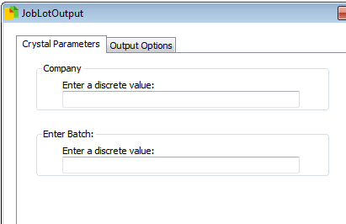Parameters

These are filters picked before running the report

* Company
  + The Syspro company ID to run against (PBL = 10)
* Batch
  + Syspro manufacturing job to review

Final Report

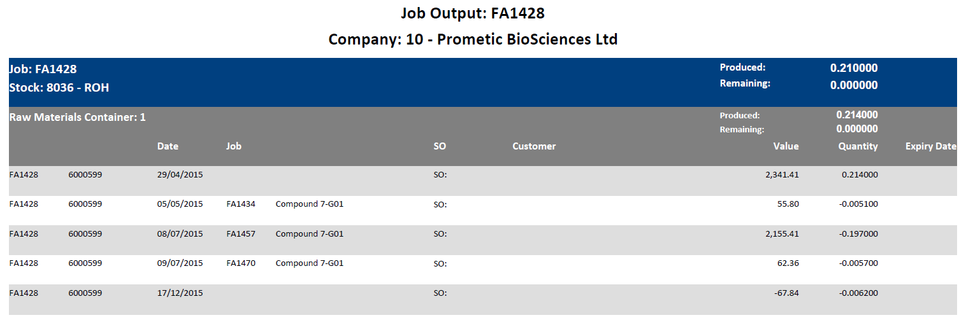

## Labour Logged Per Week

|  |  |
| --- | --- |
| Description | Details of labour logged in Syspro |
| Requested by | David Franklin |
| Delivered Date | July 2016 |
| Used by | PBL Finance |

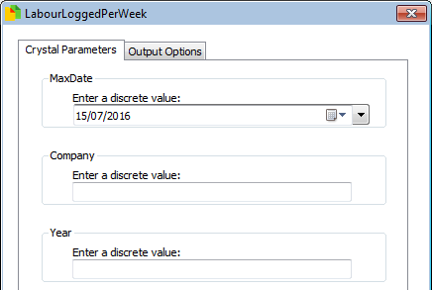Parameters

These are filters picked before running the report

* Max Date
  + Choose the end of the period to query
* Company
  + The Syspro company ID to run against (PBL = 10)
* Year
  + The GL Year to Query

Final Report

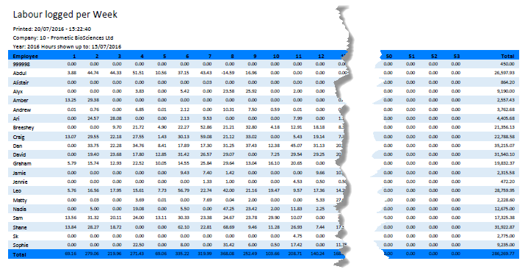

# Folder – Development

## Actuals Budgets GL Group Maps

|  |  |
| --- | --- |
| Description | Review of GL Group maps for use in other reports |
| Requested by | Bruce Pritchard |
| Delivered Date | N/A |
| Used by | N/A |

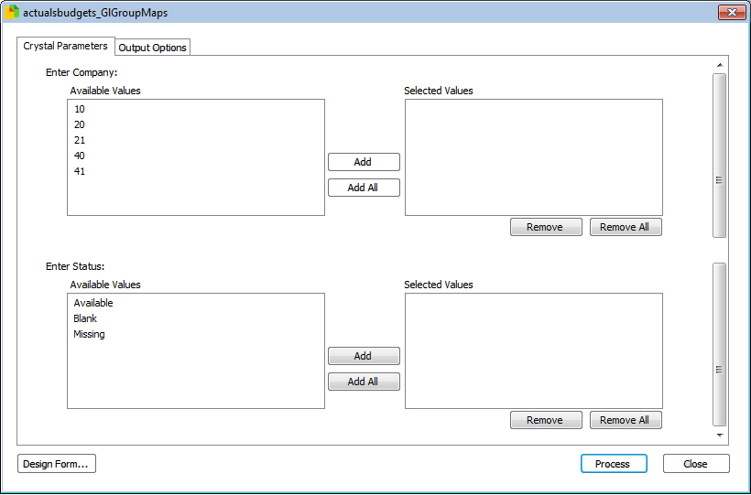Parameters

These are filters picked before running the report

* Company
  + The Syspro company ID to run against (PBL = 10)
* Status
  + Available – group has a mapping entered
  + Blank – group has a mapping that is blank, meaning it will not appear in reports
  + Missing – group does not have a map

Final Report

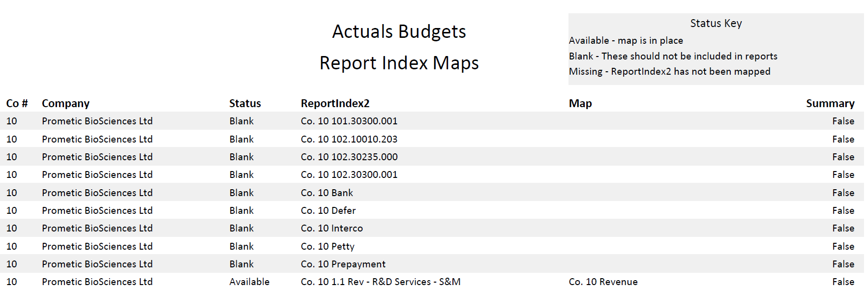

## Actuals Budgets Report Index Maps

|  |  |
| --- | --- |
| Description | Review of Report Index 2 maps for use in other reports |
| Requested by | Bruce Pritchard |
| Delivered Date | N/A |
| Used by | N/A |

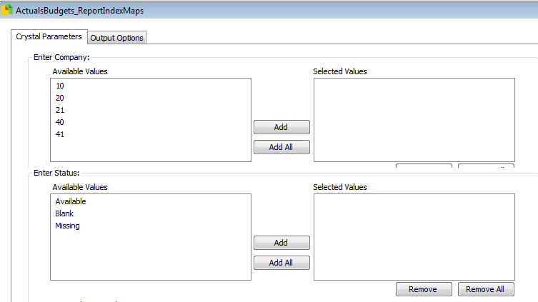Parameters

These are filters picked before running the report

* Company
  + The Syspro company ID to run against (PBL = 10)
* Status
  + Available – group has a mapping entered
  + Blank – group has a mapping that is blank, meaning it will not appear in reports
  + Missing – group does not have a map

Final Report

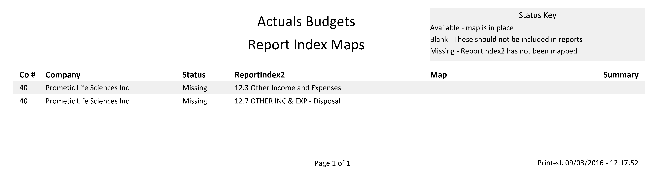

## Actuals Budgets Balance Sheet

|  |  |
| --- | --- |
| Description | Balance Sheet |
| Requested by | Bruce Pritchard |
| Delivered Date | N/A |
| Used by | N/A |

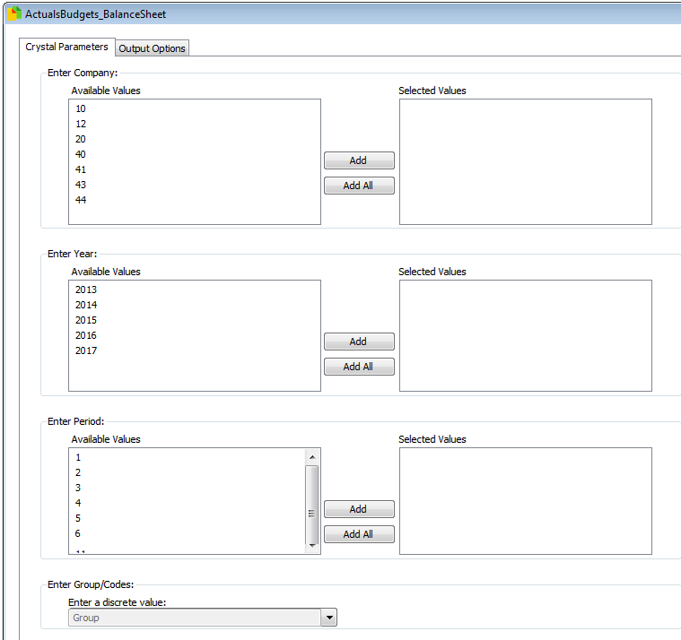Parameters

These are filters picked before running the report

* Company
  + The Syspro company ID to run against (PBL = 10)
* Year
  + Choose year
* Period
  + Choose period
* Group/Code
  + Group – Show GL Group summary
  + Code – show GL code details

Final Report

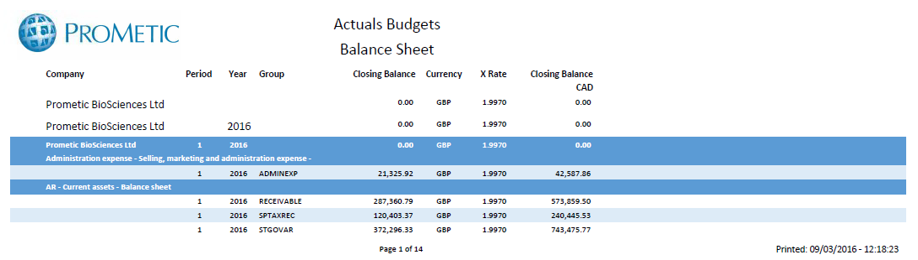

## Closing Interco Balances 3

|  |  |
| --- | --- |
| Description | Summary of Intercompany balances with new changes |
| Requested by | Bianca Vasquez |
| Delivered Date | N/A |
| Used by | PLI Finance |

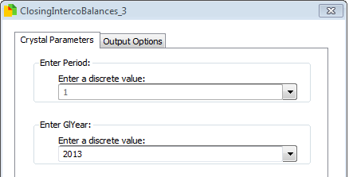 Parameters

These are filters picked before running the report

* Company
  + The Syspro company ID to run against (PBL = 10)
* Enter Period
  + Choose which GL period to review

Final Report

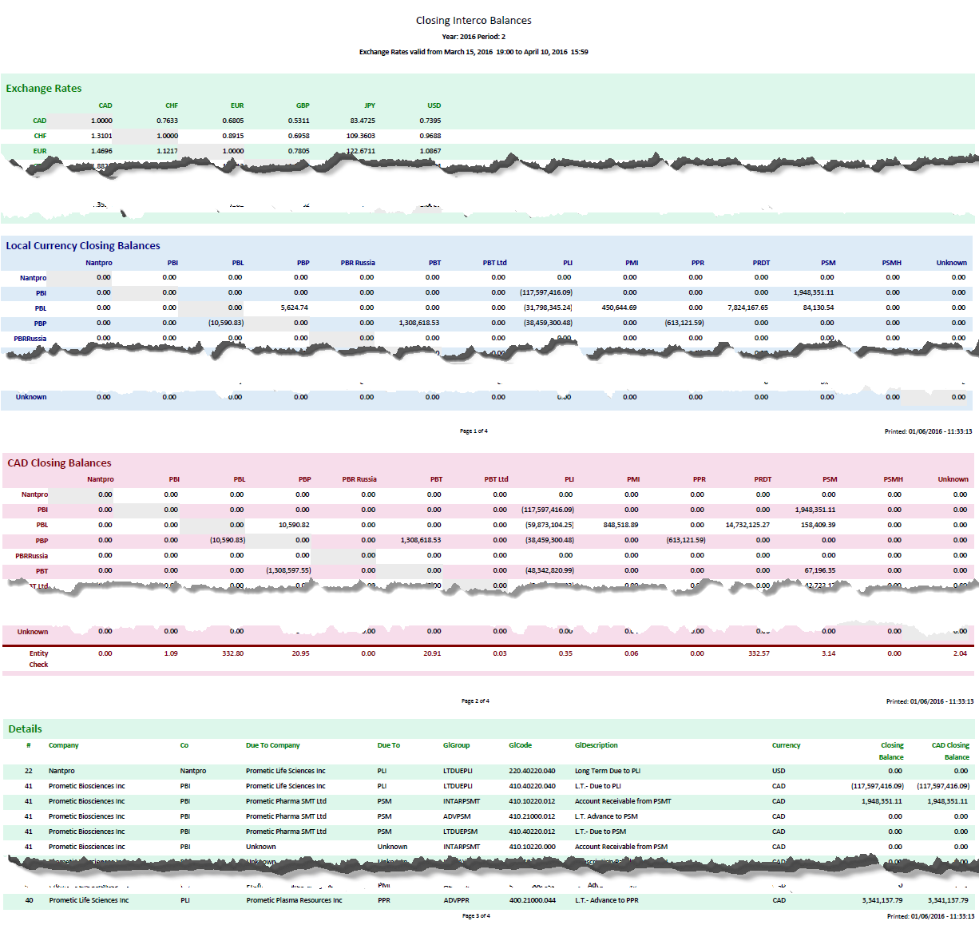

## General Ledger Journal Entries

|  |  |
| --- | --- |
| Description | Creation of an alternative GL Query that exports to excel |
| Requested by | Bianca Vasquez, Kirsty Wells |
| Delivered Date | N/A |
| Used by | N/A |

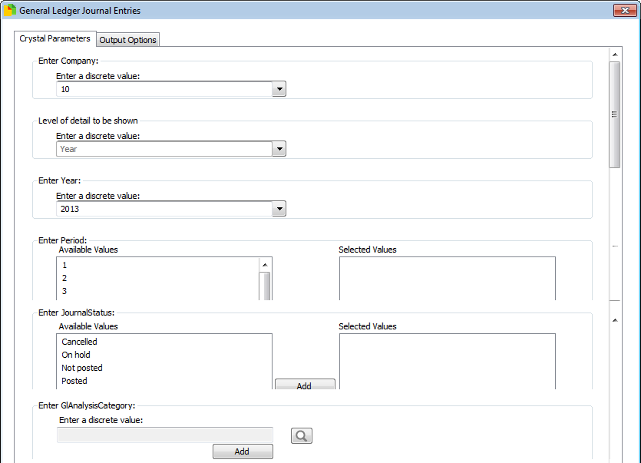Parameters

These are filters picked before running the report

* Company
  + The Syspro company ID to run against (PBL = 10)
* Level of detail to be shown
  + Define the level of grouping in the report
  + Options Year, Period, Journal, Entry
* Enter Year
  + Choose which GL Year to review
* Enter Period
  + Choose which GL period to review
* Enter Journal Status
  + Choose the status of which journals to return
* Enter GL Analysis Code
  + Optional field - if chosen, the entries are split by the analysis codes assigned to them. If this option is selected, the level of detail must be set to entry.
  + **Warning** – All Totals will remain the sum of the entries, not the analysis breakdown

Final Report

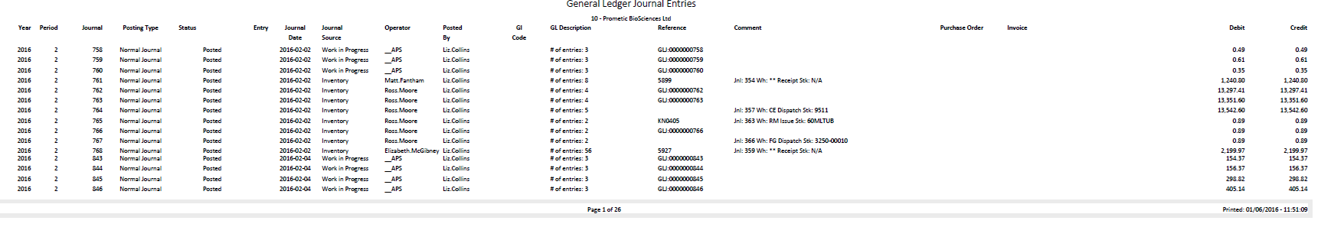

## GL Balances and Mvmts

|  |  |
| --- | --- |
| Description | List of Closing Balances and Movements for a set period |
| Requested by | Becky Glover/Liz Collins |
| Delivered Date | N/A |
| Used by | N/A |

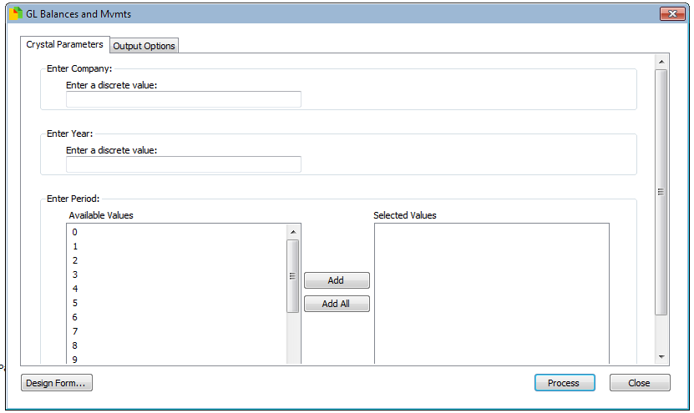Parameters

These are filters picked before running the report

* Company
  + The Syspro company ID to run against (PBL = 10)
* Enter Year
  + Choose year to query
* Enter Period
  + Choose periods to query

Final Report

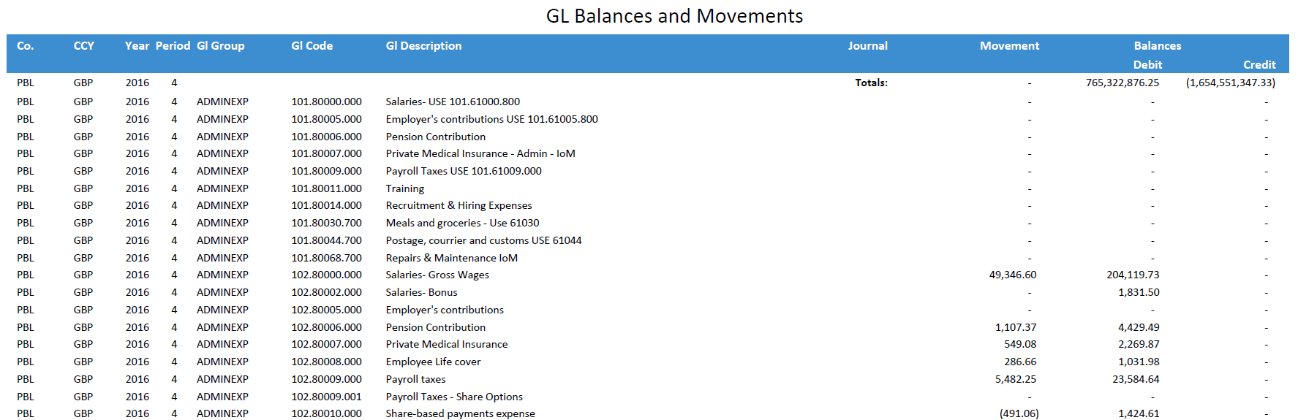

## GL Balances and Mvmts BG

|  |  |
| --- | --- |
| Description | List of Closing Balances and Movements for a set period (limited to set list of GL Codes) |
| Requested by | Becky Glover |
| Delivered Date | N/A |
| Used by | N/A |

Parameters

These are filters picked before running the report

* Company
  + The Syspro company ID to run against (PBL = 10)
* Enter Year
  + Choose year to query
* Enter Period
  + Choose periods to query

Final Report



## GL Balances and Mvmts BV

|  |  |
| --- | --- |
| Description | List of Closing Balances and Movements for a set period (limited to set list of GL Codes) |
| Requested by | Bianca Vasquez |
| Delivered Date | N/A |
| Used by | N/A |

Parameters

These are filters picked before running the report

* Company
  + The Syspro company ID to run against (PBL = 10)
* Enter Year
  + Choose year to query
* Enter Period
  + Choose periods to query

Final Report



## GL Cash Position

|  |  |
| --- | --- |
| Description | Easy querying of GL for cash positions |
| Requested by | Greg Weaver |
| Delivered Date | N/A |
| Used by | N/A |

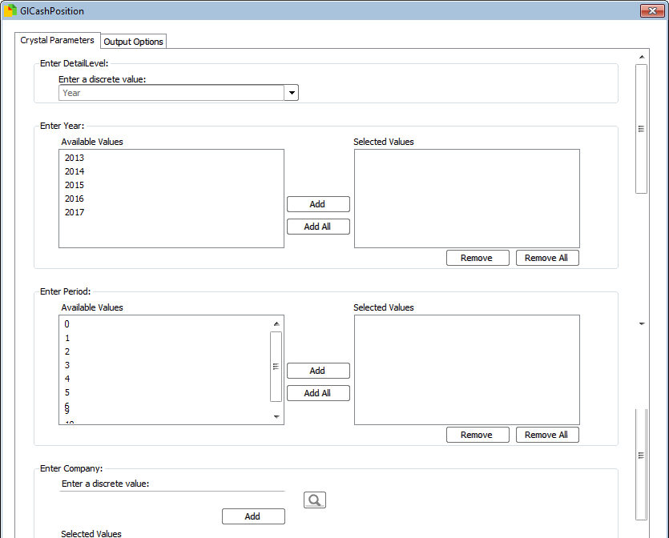Parameters

These are filters picked before running the report

* Detail Level
  + Year – only show one figure for the year for each company
  + GlCode – show the summed entries for each GlCode in each company
  + Period – show the summed entries for each period, per GlCode and company
  + Journal – show the journal lines
* Enter Year
  + Choose year to query
* Enter Period
  + Choose periods to query (for Q1, add 0, 1, 2, 3
* Company
  + The Syspro company ID to run against (PBL = 10) – if no company is selected then all companies will be shown

Final Report

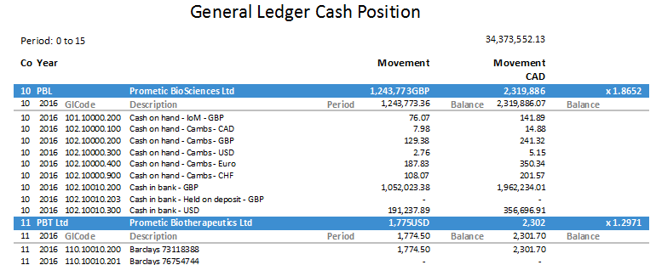

## GL Center Summary

|  |  |
| --- | --- |
| Description | Allow easy querying of GL items, such as current assets and cash |
| Requested by | Greg Weaver |
| Delivered Date | N/A |
| Used by | N/A |

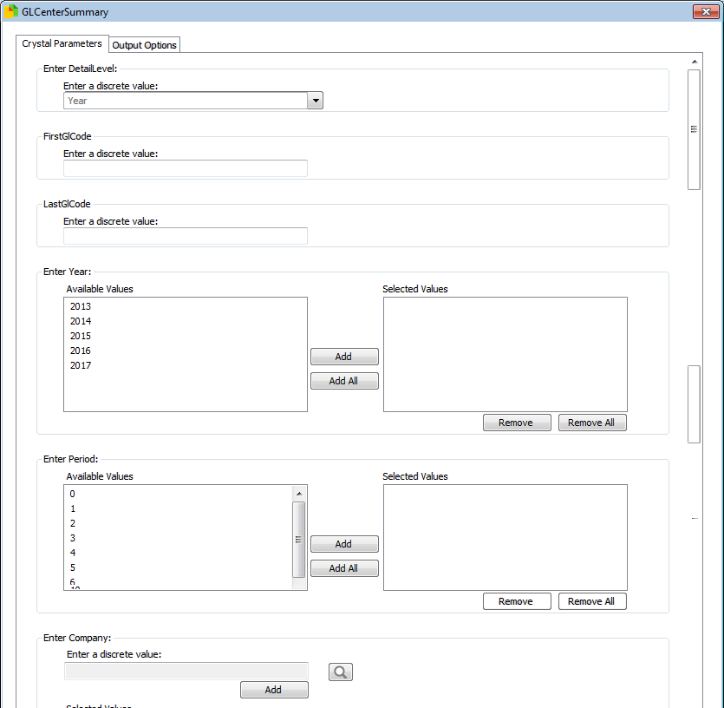Parameters

These are filters picked before running the report

* Detail Level
  + Year – only show one figure for the year for each company
  + GlCode – show the summed entries for each GlCode in each company
  + Period – show the summed entries for each period, per GlCode and company
  + Journal – show the journal lines
* First GlCode
  + Choose the start of the Gl range to query
* Last GlCode
  + Choose the start of the Gl range to query
* Enter Year
  + Choose year to query
* Enter Period
  + Choose periods to query (for Q1, add 0, 1, 2, 3
* Company
  + The Syspro company ID to run against (PBL = 10) – if no company is selected then all companies will be shown

Final Report

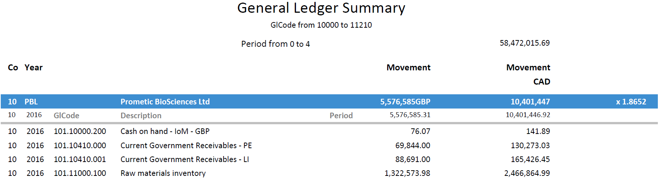

## GL Codes

|  |  |
| --- | --- |
| Description | List of GL Codes, that can be filtered to show codes that do not have a GL Group assigned |
| Requested by | Jacqueline Richard |
| Delivered Date | N/A |
| Used by | N/A |

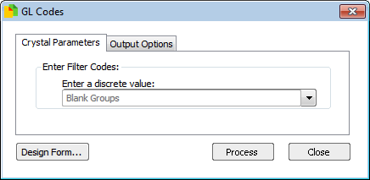Parameters

These are filters picked before running the report

* Filter
  + Blank Groups – only show GL codes that do not have a GL Group completed
  + All Codes – show all GL Codes

Final Report

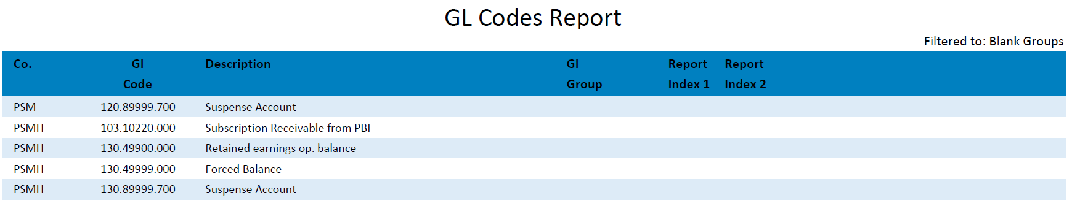

## Gl Interco PL Accounts

|  |  |
| --- | --- |
| Description | Intercompany Profit and Loss Accounts |
| Requested by | Bianca Vasquez |
| Delivered Date | - |
| Used by | PBI Finance |

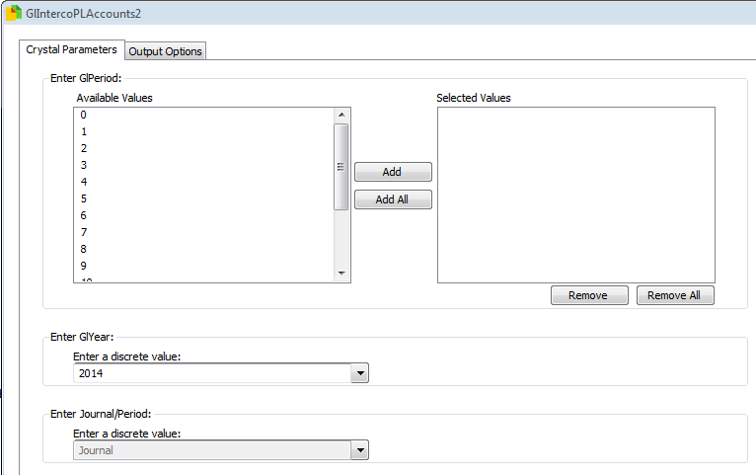Parameters

These are filters picked before running the report

* Enter GL Period
  + Choose which GL period to review
* Enter GL Year
  + Choose which GL Year to review
* Enter Journal/Period
  + Chooses Journal to show each journal, otherwise period will show the movement for the period

Final Report

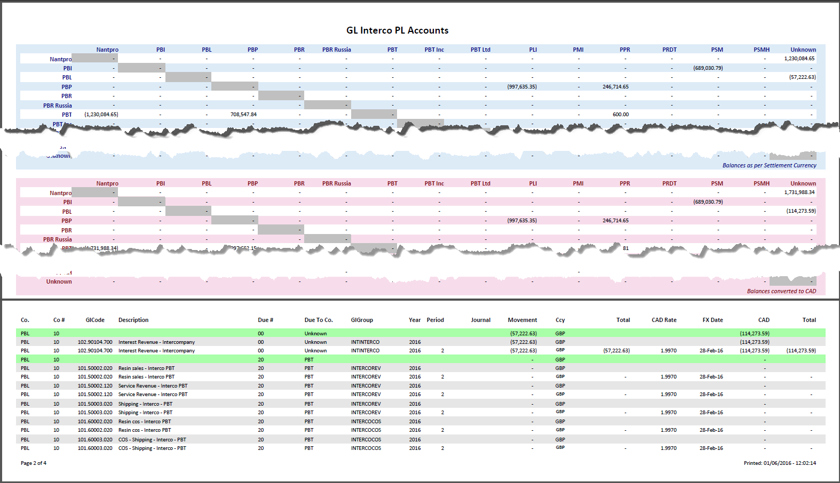

## Inventory Inspection Times Supplier Lots

|  |  |
| --- | --- |
| Description | Review of how long stock spends in inventory before being approved – altered to count supplier lots |
| Requested by | Andrew Hafford/Matt Fantham |
| Delivered Date | N/A |
| Used by | PBL QC & Finance |

Parameters

These are filters picked before running the report

* Company
  + The Syspro company ID to run against (PBL = 10)
* Year
  + Choose the year to review
* Quarter/Month
  + Choose whether to filter by quarter or month
* Enter Quarter/Month
  + Choose which quarters or months to filter by
* Detail or Summary
  + Detail – show each lot
  + Summary – show a summary line per stock code and delivery date

Final Report



## Labour Ledger Comparison

|  |  |
| --- | --- |
| Description | Comparison of Labour logged and ledger entries over a period of time |
| Requested by | David Franklin |
| Delivered Date | N/A |
| Used by | N/A |

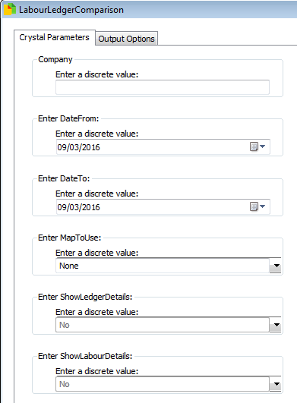Parameters

These are filters picked before running the report

* Company
  + The Syspro company ID to run against (PBL = 10)
* Date from
  + Start of period to run against
* Date to
  + End of period to run against
* Map to use
  + Which user map is to be shown in the report
* Show ledger details
  + Show ledger entries
* Show labour details
  + Show labour entries

Final Report

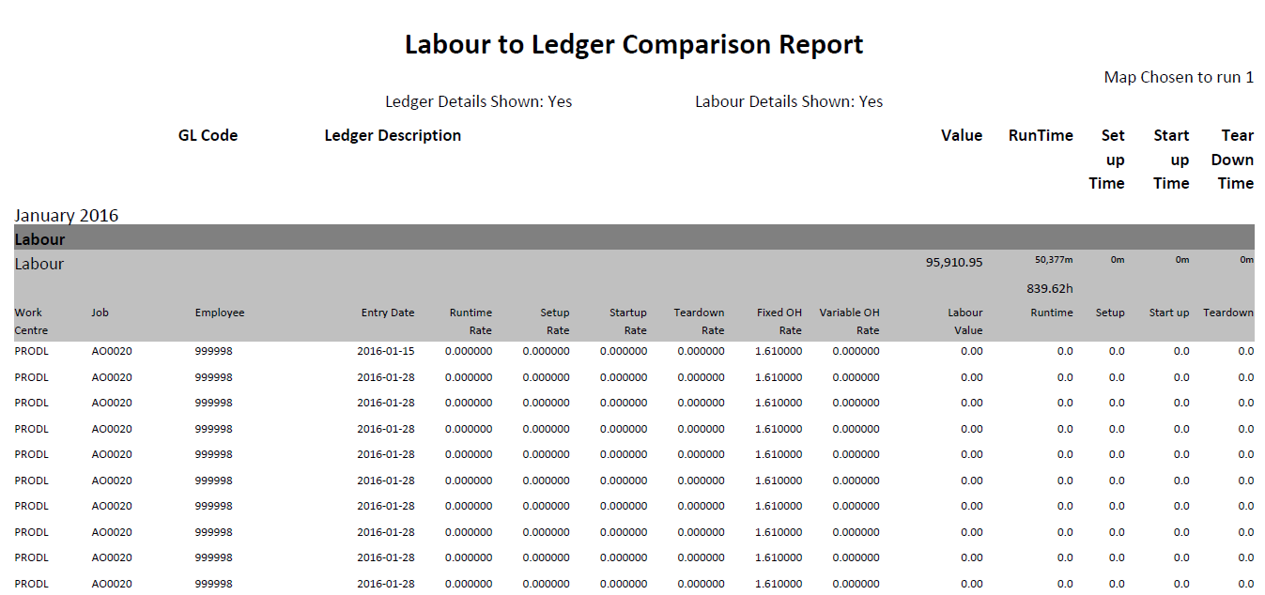

## Missing RI2 GLGroups

|  |  |
| --- | --- |
| Description | Review of all GL Codes that are missing either a GLGroup or ReportIndex2 (for use in finance reports) |
| Requested by | Bianca Vasquez |
| Delivered Date | N/A |
| Used by | N/A |

Parameters

These are filters picked before running the report

* + None

Final Report

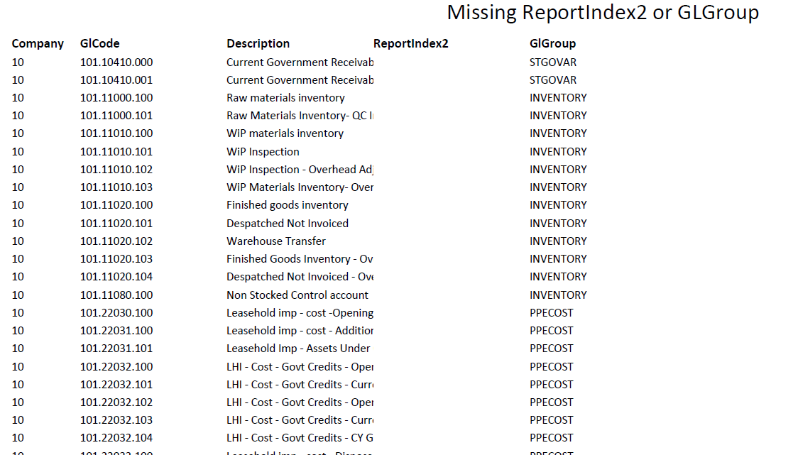

## Payment Run

|  |  |
| --- | --- |
| Description | New version of Payment run, allowing the original report to be run by Invoice number or payment number |
| Requested by | Bianca Vasquez |
| Delivered Date | N/A |
| Used by | PBI Finance |

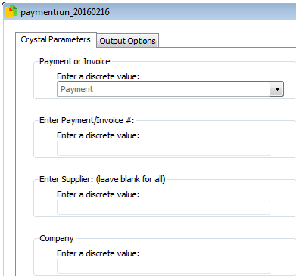Parameters

These are filters picked before running the report

* Company
  + The Syspro company ID to run against (PBL = 10)
* Payment/Invoice
  + Payment – search by payment number
  + Invoice – search by invoice number
* Payment/Invoice #
  + The reference to search
* Supplier
  + If completed, then only run against this Supplier

Final Report

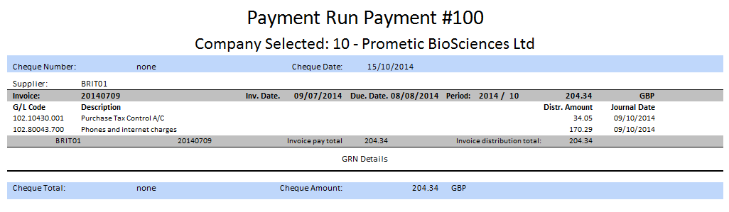

## Pick List

|  |  |
| --- | --- |
| Description | Report to find all stock for planned job (and all relevant sub jobs) |
| Requested by | Bryan Vickers |
| Delivered Date | N/A |
| Used by | PBP Manufacturing |

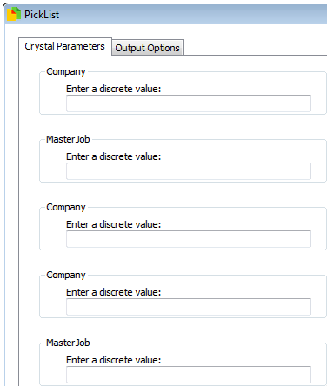Parameters

These are filters picked before running the report

* Company
  + The Syspro company ID to run against (PBL = 10)
* Master Job
  + Project job to search for

Final Report

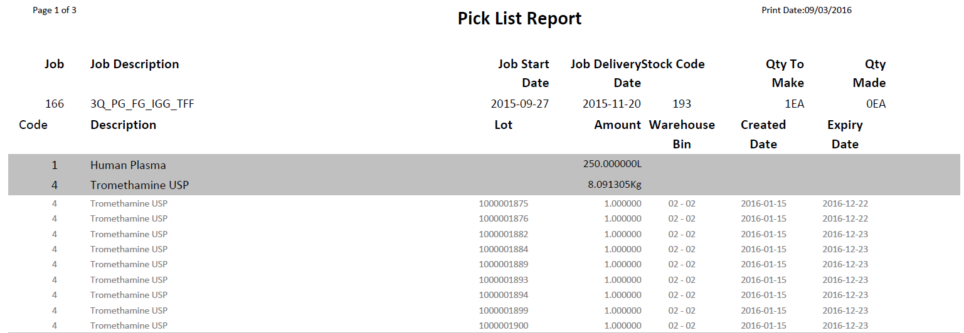

## Pick List Job Breakdown

|  |  |
| --- | --- |
| Description | Report to find all stock for planned job (and all relevant sub jobs), split by each job |
| Requested by | Bryan Vickers |
| Delivered Date | N/A |
| Used by | PBP Manufacturing |

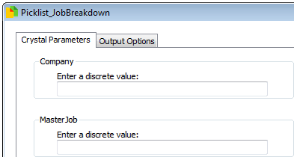Parameters

These are filters picked before running the report

* Company
  + The Syspro company ID to run against (PBL = 10)
* Master Job
  + Project job to search for

Final Report

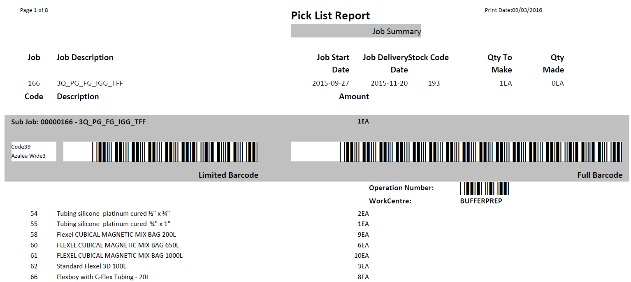

## Pick List Reserved Lots

|  |  |
| --- | --- |
| Description | Report to find all reserved stock for planned job (and all relevant sub jobs) |
| Requested by | Bryan Vickers |
| Delivered Date | N/A |
| Used by | PBP Manufacturing |

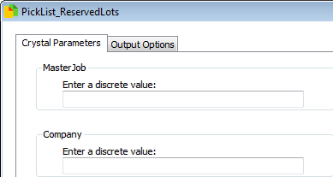Parameters

These are filters picked before running the report

* Company
  + The Syspro company ID to run against (PBL = 10)
* Master Job
  + Project job to search for

Final Report

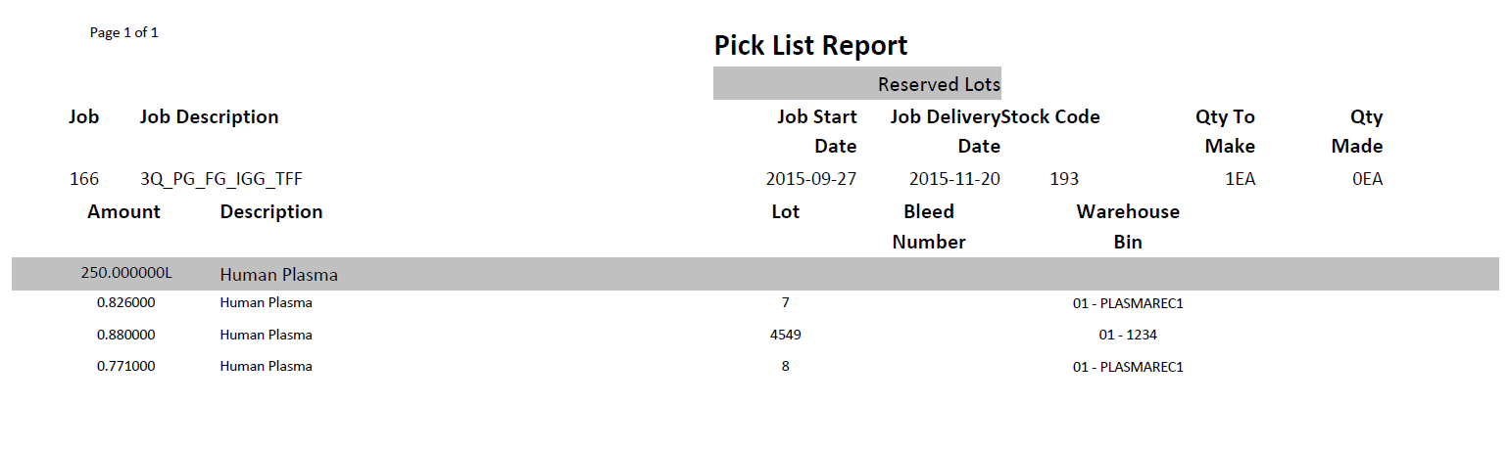

## Pick List Work Centre

|  |  |
| --- | --- |
| Description | Report to find all stock for planned job (and all relevant sub jobs), split by each work centre |
| Requested by | Bryan Vickers |
| Delivered Date | N/A |
| Used by | PBP Manufacturing |

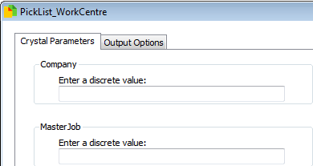Parameters

These are filters picked before running the report

* Company
  + The Syspro company ID to run against (PBL = 10)
* Master Job
  + Project job to search for

Final Report

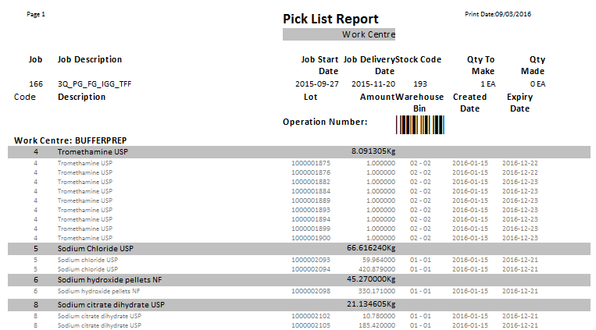

## Purchase Order Details

|  |  |
| --- | --- |
| Description | Provide details of Purchase Orders for a specified period of time |
| Requested by |  |
| Delivered Date |  |
| Used by |  |

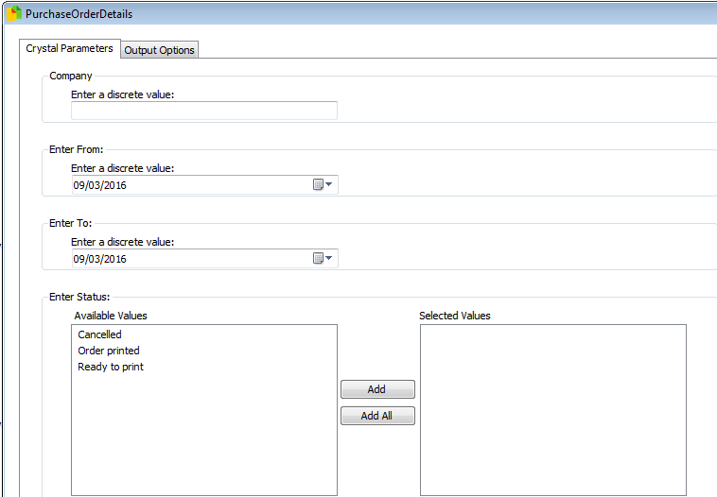Parameters

These are filters picked before running the report

* Company
  + The Syspro company ID to run against (PBL = 10)
* Enter from
  + Start of period of entry dates
* Enter to
  + End of period of entry dates
* Status
  + Purchase Order status to run against

Final Report

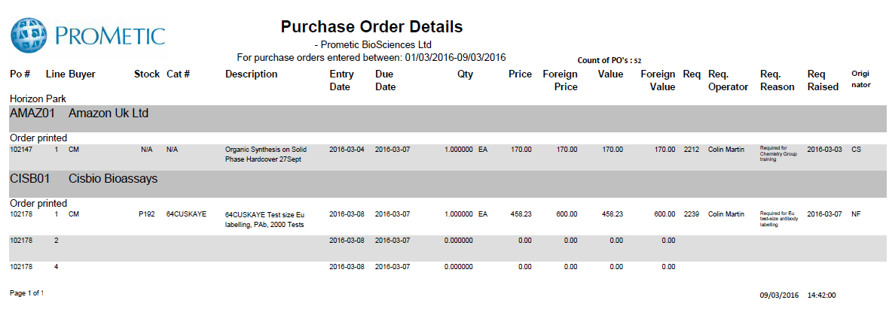

## Purchase Order E Signature

|  |  |
| --- | --- |
| Description | Report of changes made to purchase orders between two dates |
| Requested by | Liz Collins |
| Delivered Date | N/A |
| Used by | PBL Finance |

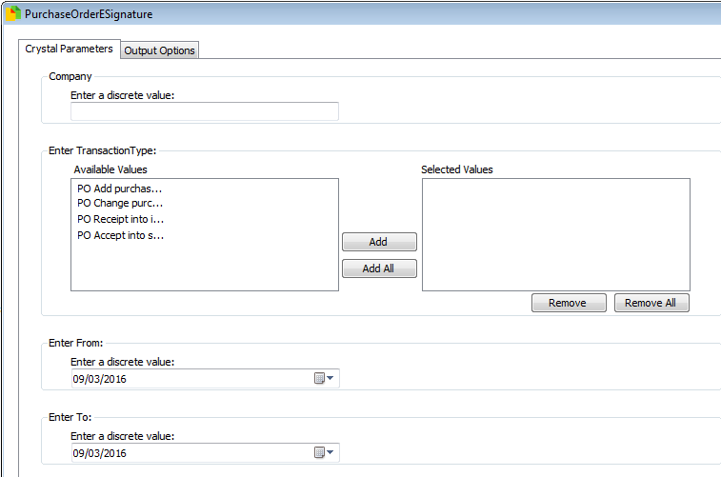Parameters

These are filters picked before running the report

* Company
  + The Syspro company ID to run against (PBL = 10)
* Transaction Type
  + Type of changes to run against
* Enter From
  + Start of period for date of change
* Enter To
  + End of period for date of change

Final Report

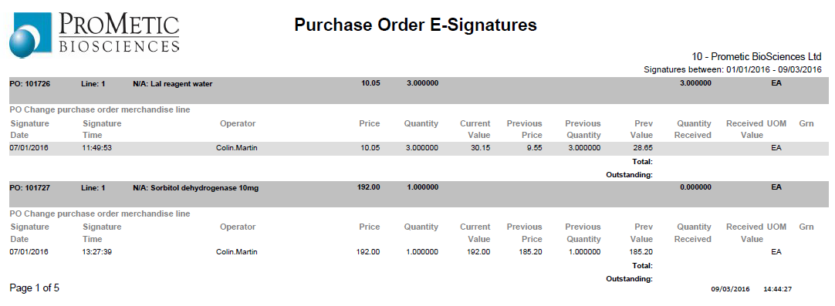

## Purchase Receipts History

|  |  |
| --- | --- |
| Description | Details of Purchase Order with matching Receipts |
| Requested by | Liz Collins |
| Delivered Date | - |
| Used by | N/A |

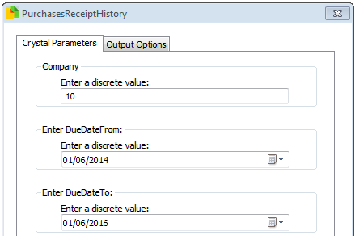Parameters

These are filters picked before running the report

* Company
  + The Syspro company ID to run against (PBL = 10)
* Enter Due Date From
* Enter Due Date To

Final Report

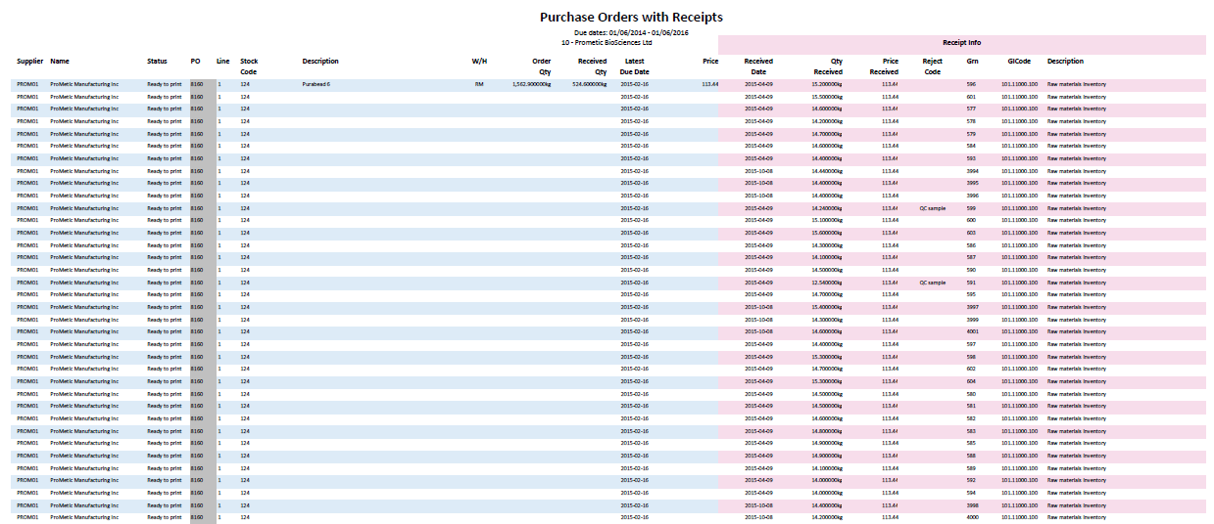

## Purchases by Supplier

|  |  |
| --- | --- |
| Description | Accounts Payable – Unpaid Assets, created by Prometic |
| Requested by | Benjamin Hemond |
| Delivered Date | - |
| Used by | N/A |

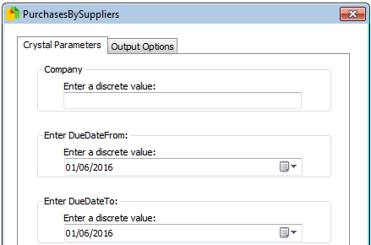Parameters

These are filters picked before running the report

* Company
  + The Syspro company ID to run against (PBL = 10)
* Enter Due Date From
* Enter Due Date To

Final Report

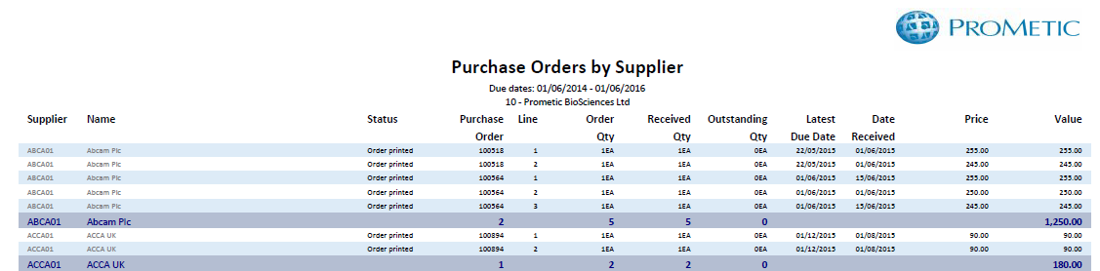

## Report System Refresh

|  |  |
| --- | --- |
| Description | Report used to generate data for other reports, run every 30 mins |
| Requested by | N/A |
| Delivered Date | - |
| Used by | N/A |

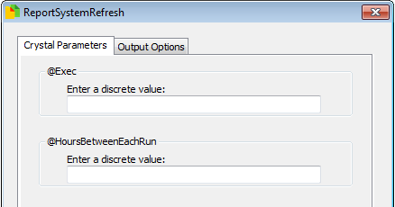Parameters

These are filters picked before running the report

* @Exec
  + If set to 1 then the report will generate new lookups
* @HoursBetweenEachRun
  + This determines how long should be between each load, if this is not met, the changes are not recorded

Final Report

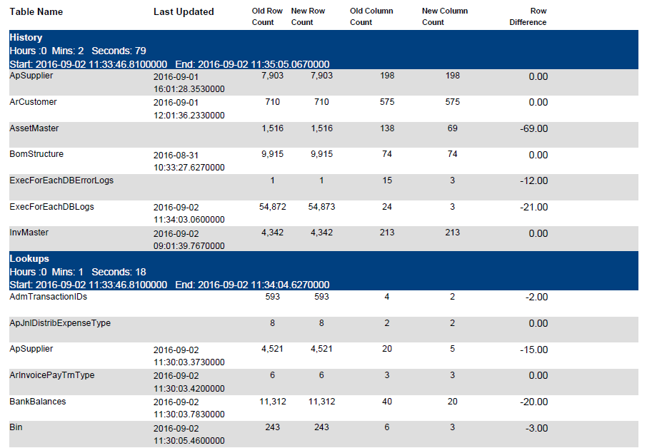

## Review of Reports

|  |  |
| --- | --- |
| Description | Report to ahow health status and usage of report systems |
| Requested by | N/A |
| Delivered Date | - |
| Used by | N/A |

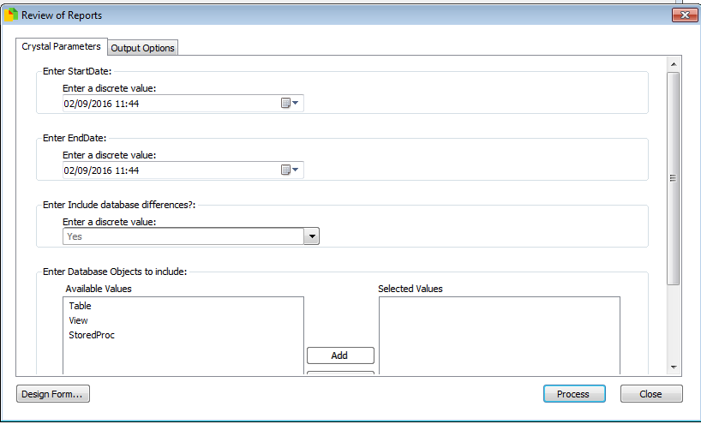

Parameters

These are filters picked before running the report

* StartDate
  + Start of period to query which reports run in
* EndDate
  + End of period to query which reports run in
* Include database differences
  + Choose whether to review differences in Syspro databases
* Database objects
  + Choose the objects to review differences on

*\*\*Full guide written separately\*\**

Final Report

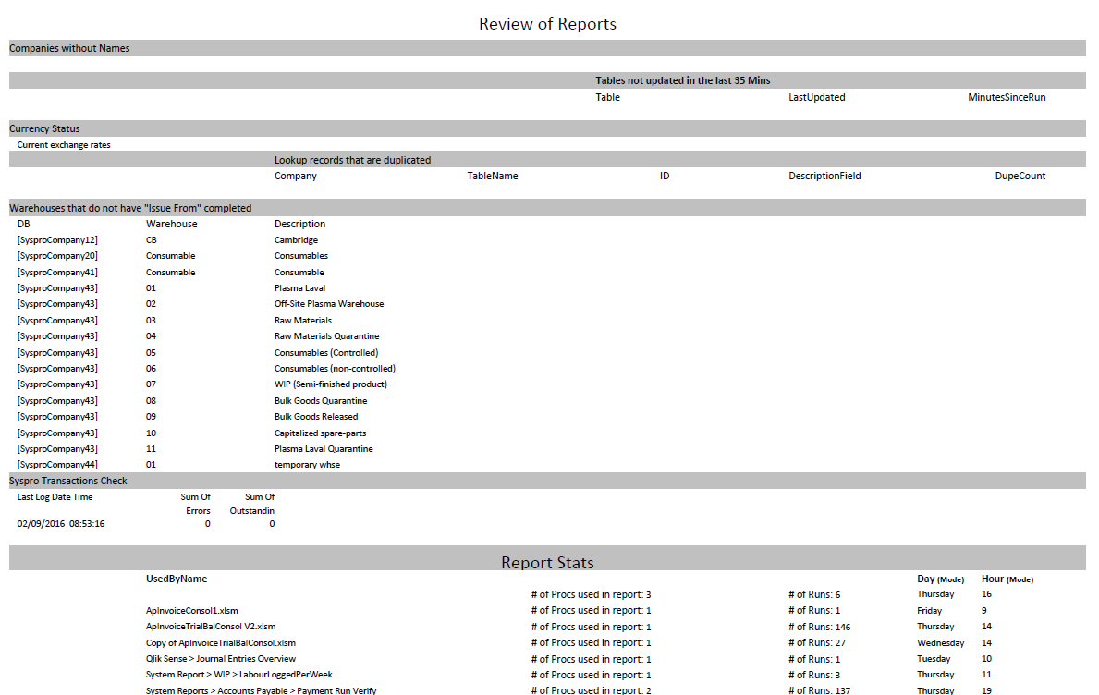

## Trial Balance

|  |  |
| --- | --- |
| Description | Copy of Trial Balance put in place for future developments |
| Requested by | N/A |
| Delivered Date | - |
| Used by | N/A |

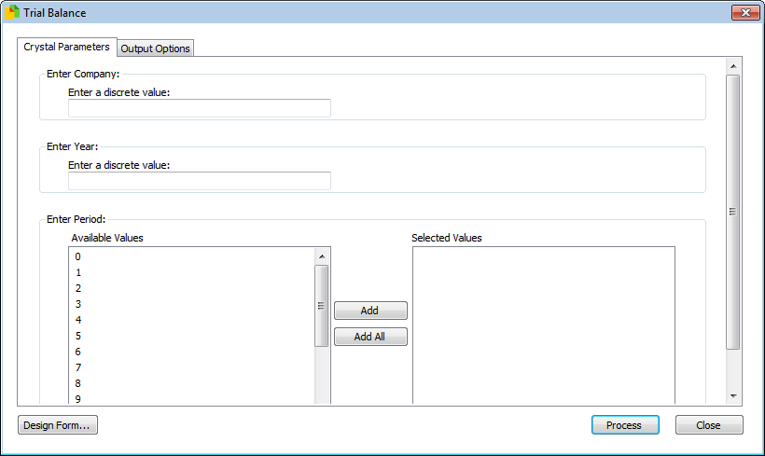Parameters

These are filters picked before running the report

* Company
  + The Syspro company ID to run against (PBL = 10)
* Year
* Period

Final Report

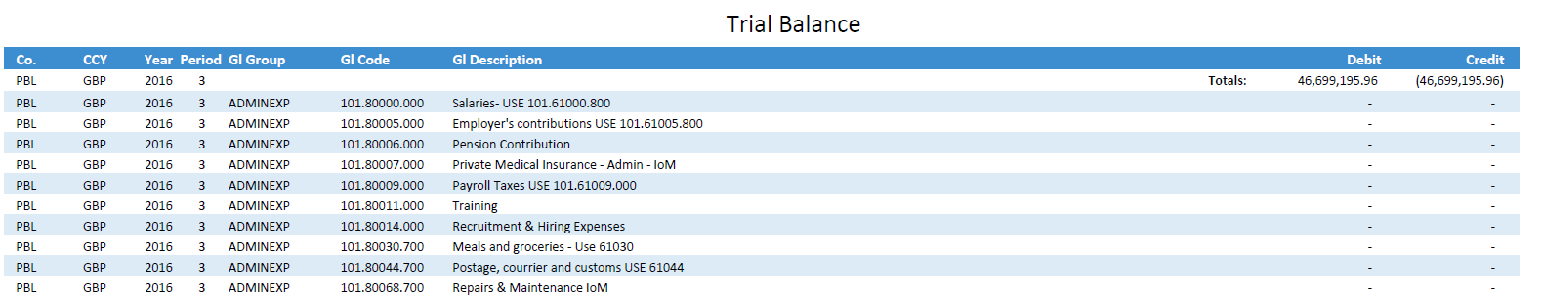

## Unpaid Assets Accounts Payable

|  |  |
| --- | --- |
| Description | Accounts Payable – Unpaid Assets, created by Prometic |
| Requested by | Bianca Vasquez |
| Delivered Date | - |
| Used by | PBI/PBL finance |

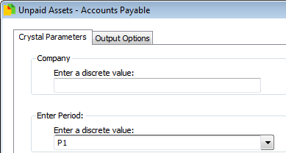Parameters

These are filters picked before running the report

* Company
  + The Syspro company ID to run against (PBL = 10)
* Period
  + P1 – this period
  + P2 – last period
  + P3 – last period – 1

Final Report

